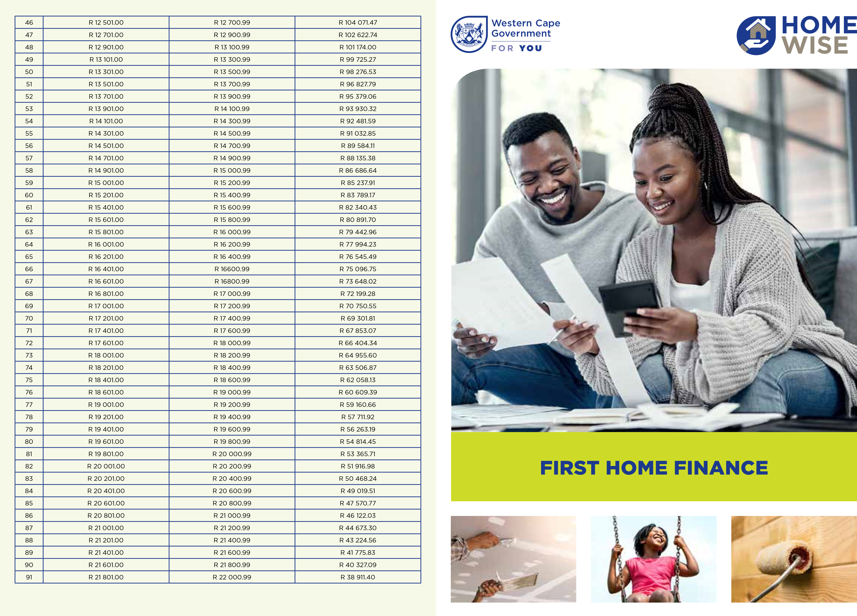

1. WHAT YOU GET
If your household income is between R3,501 and R22,000 per month, you may qualify to purchase your first home using the First Home Finance subsidy. See the sliding scale to determine your subsidy amount.
This subsidy can be used by first-time home buyers to:
- Buy an existing house / apartment
- Buy a serviced residential site (ie. plot of land with access to basic services - Applicants must be registered on the Western Cape Housing Demand Database) for 3 years.
- Build a house on a serviced residential site, if the site was not acquired through a government housing subsidy in the past. Note that your builder must be registered with the National Home Builder Registration Council (NHBRC) to ensure building and safety standards.
Applicants can access this subsidy using one of these options:
^{FINANCE} OPTIONS REQUIREMENTS
Mortgage An approved home loan. You can also apply retrospectively, i.e. if you purchased a
Loan residential property and it has been transferred into your name not longer than 6 months ago.
Pension- A loan provided by a financial institution secured by your pension savings. Your backed loan pension fund and the financial institution must have entered into an arrangement.
Rent to Buy Agreement with your Landlord to purchase the property you have been renting. You should only apply for the subsidy at the point of purchase and you have secured the necessary finance to make the purchase.
No financial If the subsidy amount that you qualify for is equal to, or greater than, the purchase Contribution price of the property. The subsidy can also be used to cover transfer, bond regisRequired tration costs, or a shortfall on the bond.
Cash From your own savings. No retrospective application for cash. Each contribution to be paid to attorneys prior to application.

2. WHAT YOU NEED TO QUALIFY
- Your gross household income is between R3,501 and R22,000 per month, ie. Basic household income, plus housing allowance where applicable.
- You are a South African citizen or have a permanent residency permit
- You are over 18 years and competent to contract
- You are married or cohabiting OR single with financial dependents
- You haven’t received a government housing subsidy before 6. You haven’t owned fixed residential property before 7. Attorneys to be CSD registered and attach proof.

3. HOW TO APPLY
Once your finance is secured to purchase your first home, contact the Department of Infrastructure to complete the application form.
- Visit 27 Wale Street, Cape Town
- Call the Help Desk on 021 483 6488/0611/3112/0623/2060
(Monday to Friday from 07:30 15:00) • Email: human.settlements@westerncape.gov.za; or • Visit the departmental website: www.westerncape.gov.za/tpw/department-of-infrastructure
You can also contact your nearest municipality regarding this programme.
Step Income band
Lower Higher Subsidy Amount

1 R 3 501.00 R 3 700.99 R 169 264.60
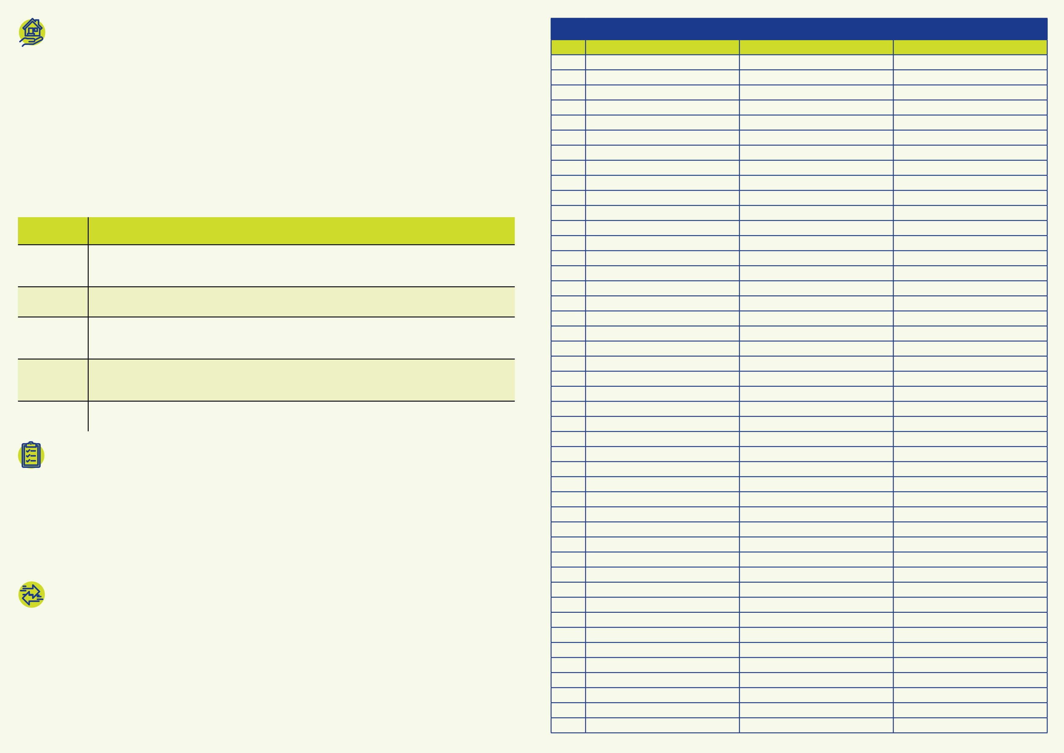
2 R 3 701.00 R 3 900.99 R 167 815.86 3 R 3 901.00 R 4 100.99 R 166 367.12 4 R 4 101.00 R 4 300.99 R 164 918.39 5 R 4 301.00 R 4 500.99 R 163 469.65 6 R 4 501.00 R 4 700.99 R 162 020.92 7 R 4 701.00 R 4 900.99 R 160 572.18 8 R 4 901.00 R 5 100.99 R 159 123.44 9 R 5 101.00 R 5 300.99 R 157 674.71

10 R 5 301.00 R 5 500.99 R 156 225.97
11 R 5 501.00 R 5 700.99 R 154 777.24 12 R 5 701.00 R 5 900.99 R 153 328.50 13 R 5 901.00 R 6 100.99 R 151 879.76 14 R 6 101.00 R 6 300.99 R 150 431.03 15 R 6 301.00 R 6 500.99 R 148 982.29 16 R 6 501.00 R 6 700.99 R 147 533.56

17 R 6 701.00 R 6 900.99 R 146 084.82 18 R 6 901.00 R 7 100.99 R 144 636.08 19 R 7 101.00 R 7 300.99 R 143 187.35 20 R 7 301.00 R 7 500.99 R 141 738.61 21 R 7 501.00 R 7 700.99 R 140 289.88 22 R 7 701.00 R 7 900.99 R 138 841.14 23 R 7 901.00 R 8 100.99 R 137 392.40 24 R 8 101.00 R 8 300.99 R 135 943.67 25 R 8 301.00 R 8 500.99 R 134 494.93 26 R 8 501.00 R 8 700.99 R 133 046.20 27 R 8 701.00 R 8 900.99 R 131 597.46 28 R 8 901.00 R 9 100.99 R 130 148.72 29 R 9 101.00 R 9 300.99 R 128 699.99 30 R 9 301.00 R 9 500.99 R 127 251.25 31 R 9 501.00 R 9 700.99 R 125 802.52 32 R 9 701.00 R 9 900.99 R 124 353.78 33 R 9 901.00 R 10 100.99 R 122 905.04 34 R 10 101.00 R 10 300.99 R 121 456.31 35 R 10 301.00 R 10 500.99 R 120 007.57 36 R 10 501.00 R 10 700.99 R 118 558.83 37 R 10 701.00 R 10 900.99 R 117 110.10 38 R 10 901.00 R 11 100.99 R 115 661.36 39 R 11 101.00 R 11 300.99 R 114 212.63 40 R 11 301.00 R 11 500.99 R 112 763.89 41 R 11 501.00 R 11 700.99 R 111 315.15 42 R 11 701.00 R 11 900.99 R 109 866.42 43 R 11 901.00 R 12 100.99 R 108 417.68 44 R 12 101.00 R 12 300.99 R 106 968.95 45 R 12 301.00 R 12 500.99 R 105 520.21

