Inc, Attorneys practising at 168 Vasco Boulevard, Goodwood hereby certify

that :-
The property described as:
PORTION OF PORTION 4 (PORTION OF PORTION
3) of the KLEINE BERG RIVIER NR 1
In the Drakenstein Municipality
Division Tulbagh, Western Cape Province
In Extent 196,7506 Hectares
Is registered in the names of :
AJ DU PLESSIS BOERDERY (PTY) LTD
REGISTRATION NUMBER: 1999/002098/07
- And held by Title Deed Number T34338/2004
- Summary of conditions contained in abovementioned Title Deed annexed hereto together with all relevant Deeds.
- There are no further bonds registered over the property.
There are no interdicts registered over the property.
DATED AT oood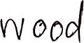 THIS I DAY OF NovembeD2019
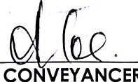
CO
VEYANCER
Inc, Attorneys practising at 168 Vasco Boulevard, Goodwood hereby certify that :-
The property described as:
PORTION 9 (PORTION OF PORTION 8) OF THE
FARM HARTEBEESTE KRAAL NR 88
In the Drakenstein Municipality
Division Tulbagh, Western Cape Province
In Extent 188,0368 Hectares
Is registered in the names of :
The trustees for the time being of the
AJ DU PLESSIS TRUST
REGISTRATION NUMBER: IT 1604/2000
- And held by Deed of Transfer Number T64894/2010
- Summary of conditions contained in abovementioned Title
Deed annexed hereto together with all relevant Deeds.
There are no further bonds registered over the property.
(vi) There are no interdicts registered over the property.
 THIS I DAY OF
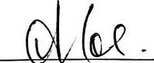
CONVEYANCER
Inc, Attorneys practising at 168 Vasco Boulevard, Goodwood hereby certify
that :-
The property described as:
PORTION 1 1 (PORTION OF PORTION 1) of the
Farm Bonne Esperance Number 83
In the Drakenstein Municipality
Division of Tulbagh, Western Cape Province
In Extent 224,8427 Hectares
Is registered in the names of :
The trustees for the time being of the
AJ DU PLESSIS TRUST
REGISTRATION NUMBER: IT 1604/2000
- And held by Title Deed Number T36842/2015
- Summary of conditions contained in abovementioned Title Deed annexed hereto together with all relevant Deeds.
- There are no further bonds registered over the property.
- There are no interdicts registered over the property.
 THIS I DAY OF 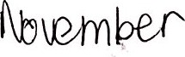 2019
C | V ANCER
Inc, Attorneys practising at 168 Vasco Boulevard, Goodwood hereby certify that :-
The property described as:
THE FARM NAYOTH NUMBER 458
In the Drakenstein Municipality
Division Tulbagh, Western Cape Province
In Extent 1 184,7218 Hectares
Is registered in the names of :
AJ DU PLESSIS BOERDERY (PTY) LTD
REGISTRATION NUMBER: 1999/002098/07
- And held by Certificate of Consolidated Title Number T29764/2018
- Summary of conditions contained in abovementioned Title Deed annexed hereto together with all relevant Deeds.
- There are no further bonds registered over the property.
There are no interdicts registered over the property.
eecdwccd THIS I DAY OF (\JOWfüfr2019
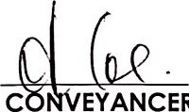
EYANCER

l'
Inc, Attorneys practising at 168 Vasco Boulevard, Goodwood hereby certify that :-
The property described as:
THE FARM DE MOND NUMBER 457
In the Drakenstein Municipality
Division Tulbagh, Western Cape Province
In Extent 92,9597 Hectares
Is registered in the names of :
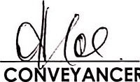
DE MOND PROPERTIES (PTY) LTD
CO
VEYANCER
REGISTRATION NUMBER: 2017/204788/07
- And held by Deed of Transfer Number T29763/2018
- Summary of conditions contained in abovementioned Title
Deed annexed hereto together with all relevant Deeds.
There are no further bonds registered over the property.
(vi) There are no interdicts registered over the

property.
DATED AT Occtwcccl THIS DAY OF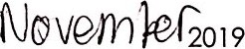
l,
Inc, Attorneys practising at 168 Vasco Boulevard, Goodwood hereby certify that
The property described as:
PORTION 1 of the Farm Bonne Esperance
Number 83
In the Drakenstein Municipality
Division Tulbagh, Western Cape Province
In Extent 1333,0929 Hectares
Is registered in the names of :
CO | EYANCER
The trustees for the time being of the
AJ DU PLESSIS TRUST
REGISTRATION NUMBER: IT 1604/2000
- And held by Title Deed Number T72857/2005
- Summary of conditions contained in abovementioned Title
Deed annexed hereto together with all relevant Deeds. There are no further bonds registered over the property.
There are no interdicts registered over the property.
DATED AT 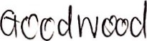 THIS DAY OF  2019

