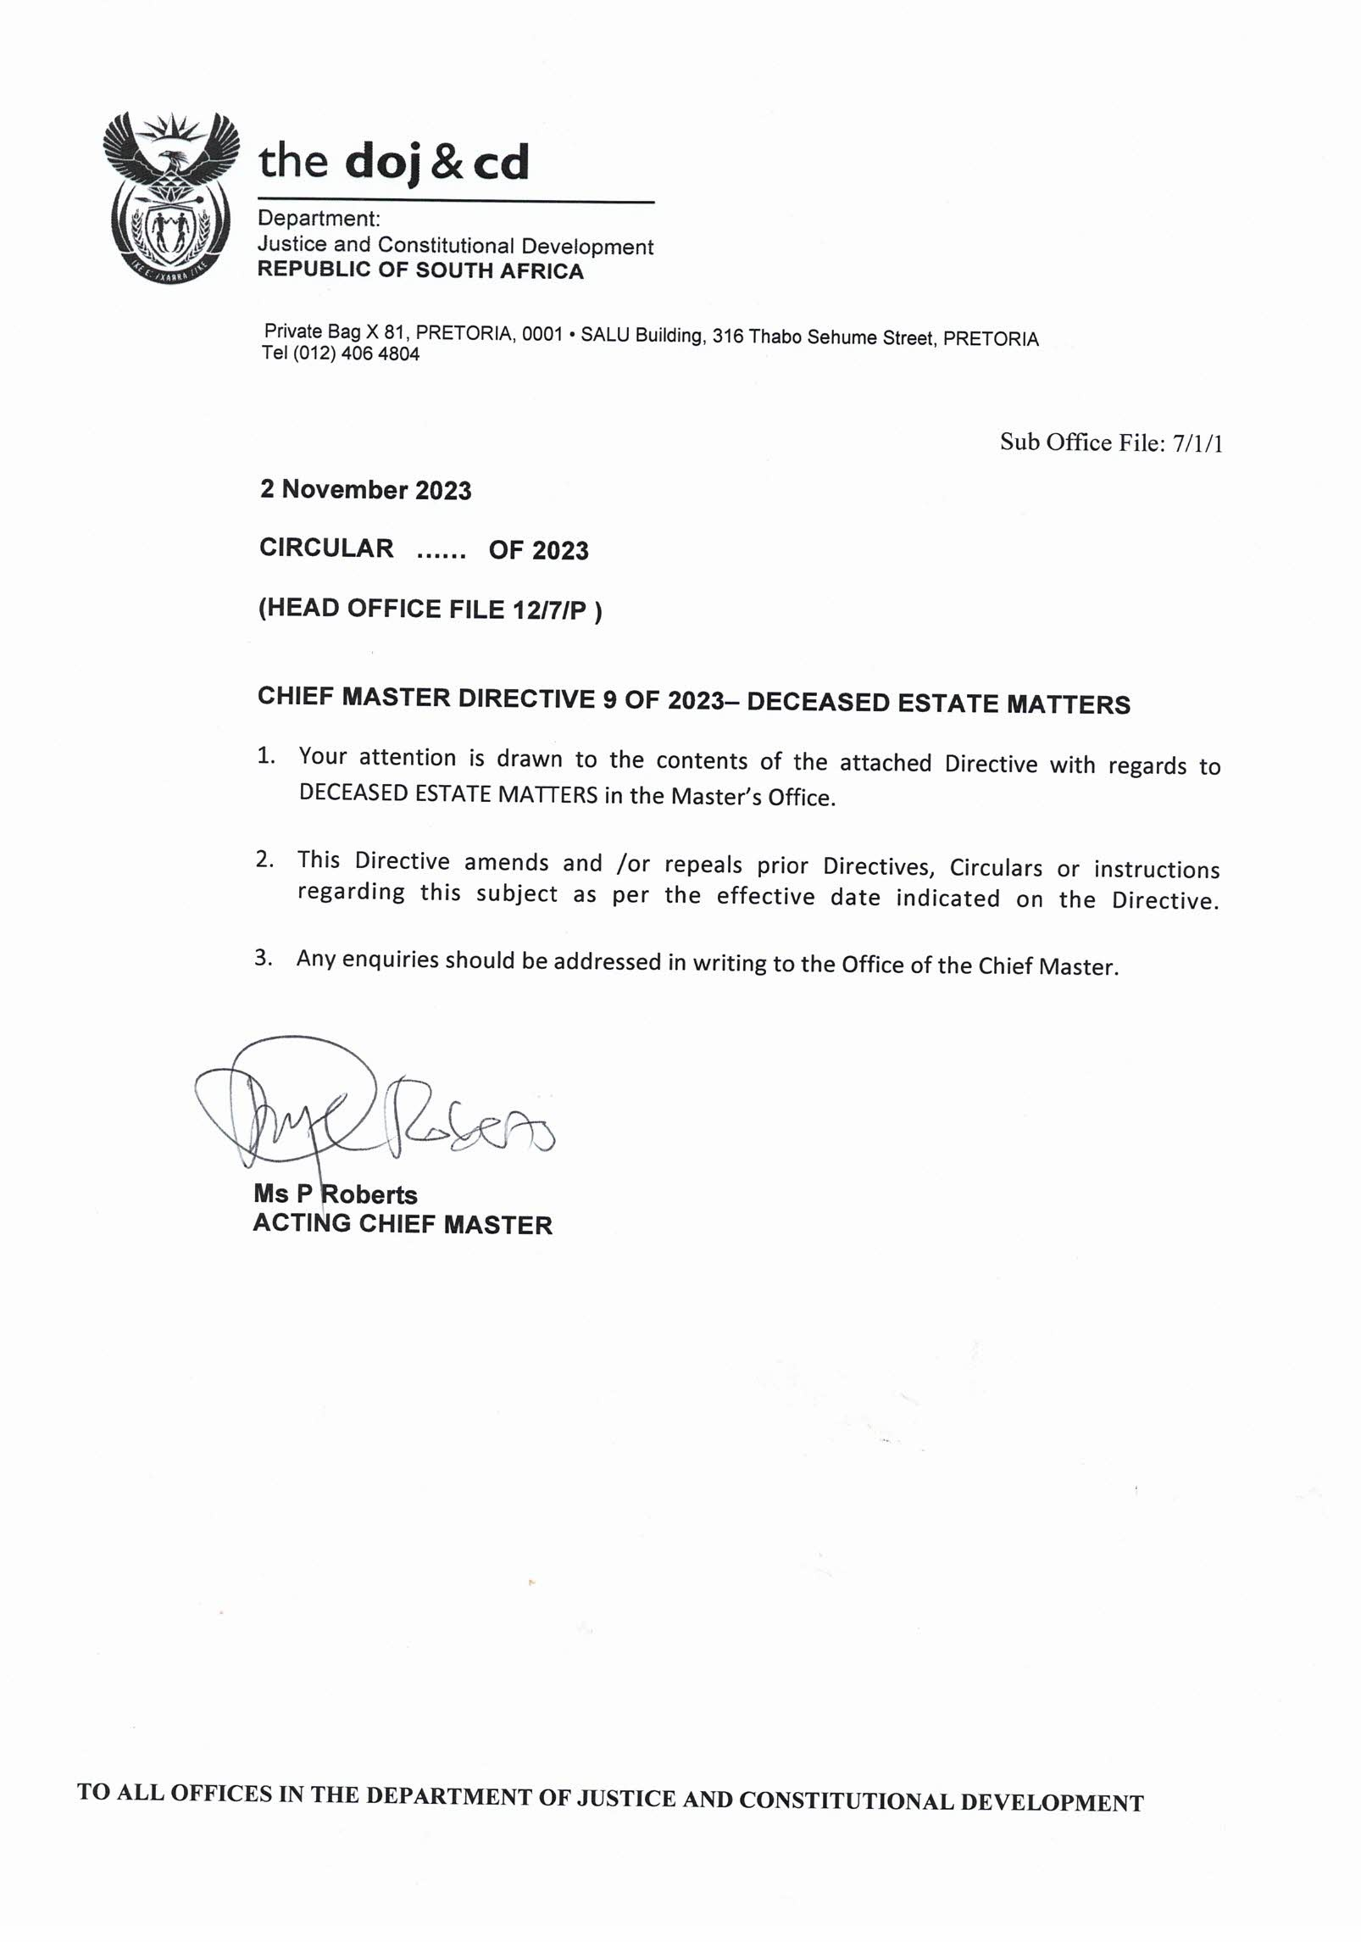

61

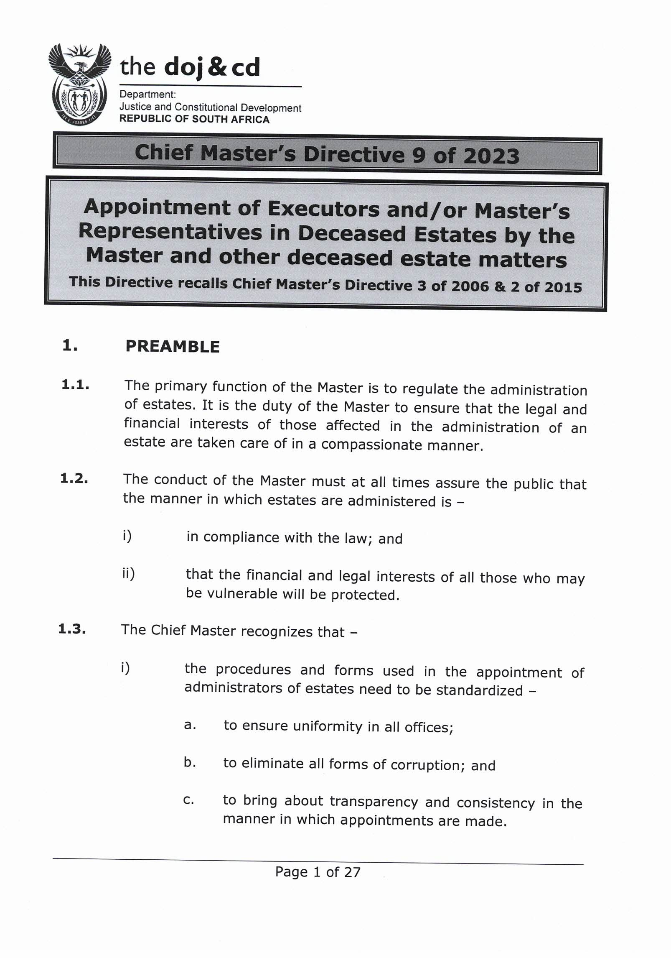

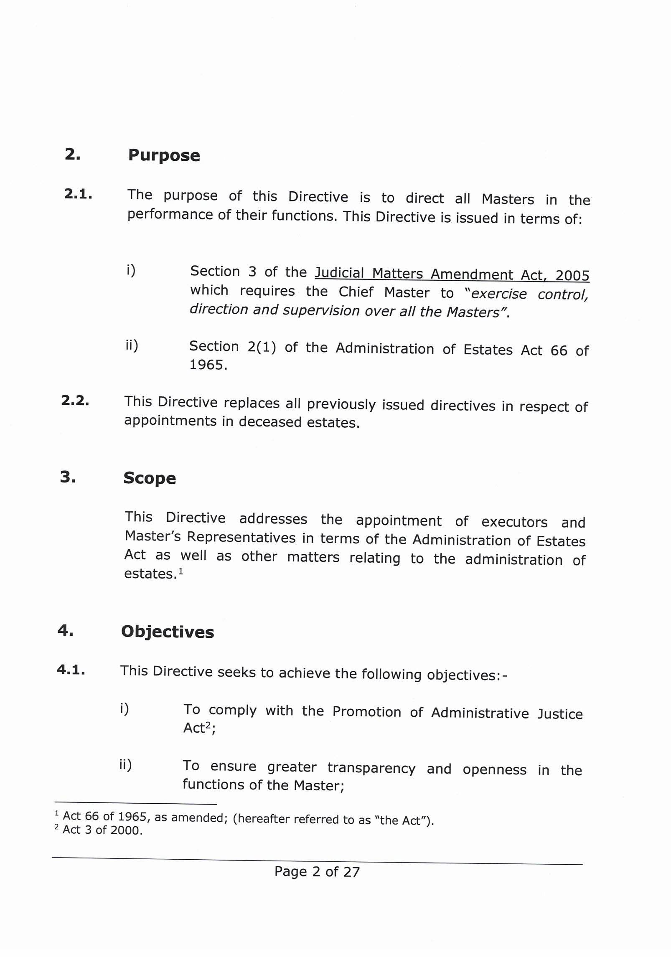

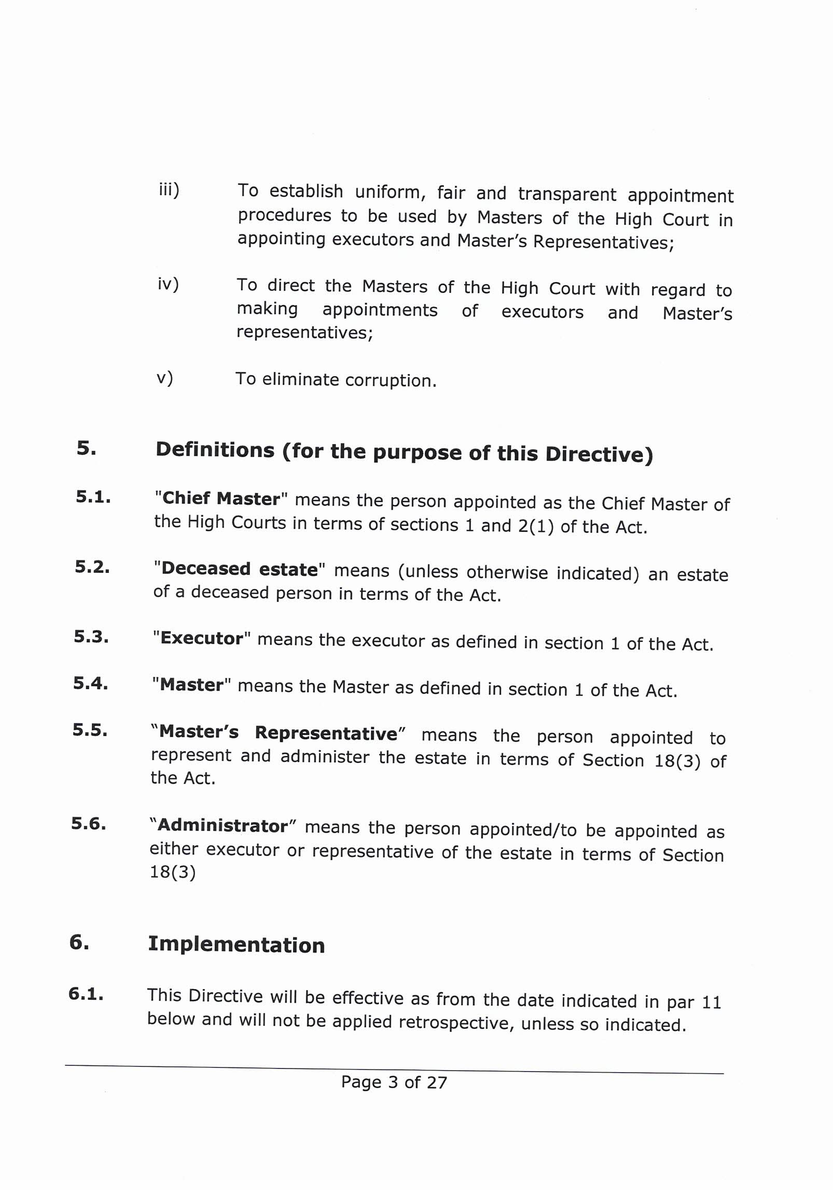

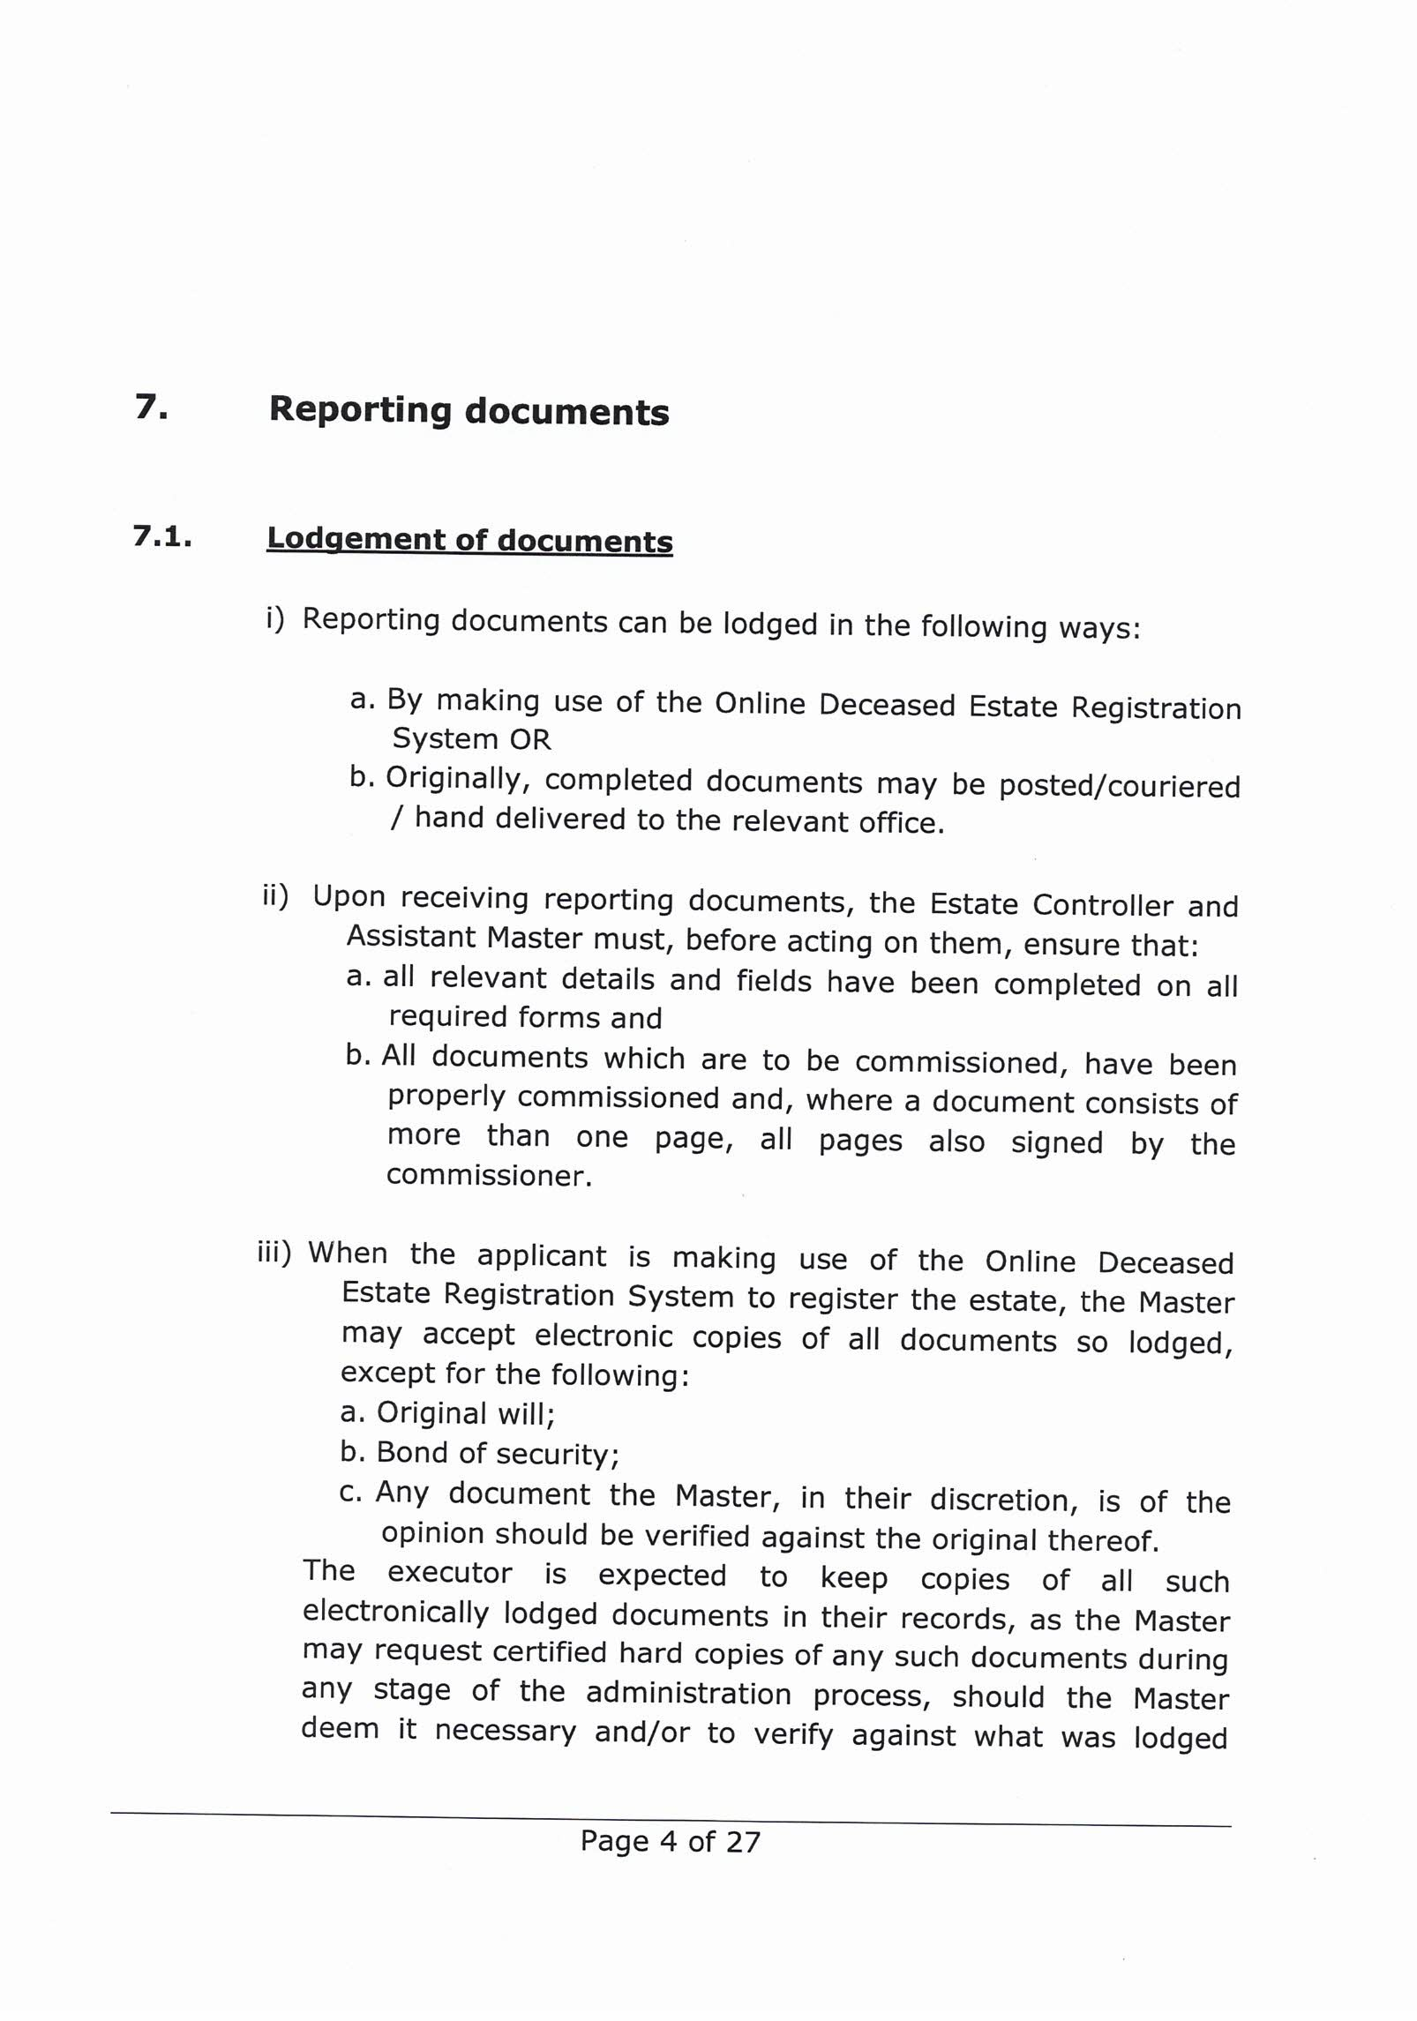

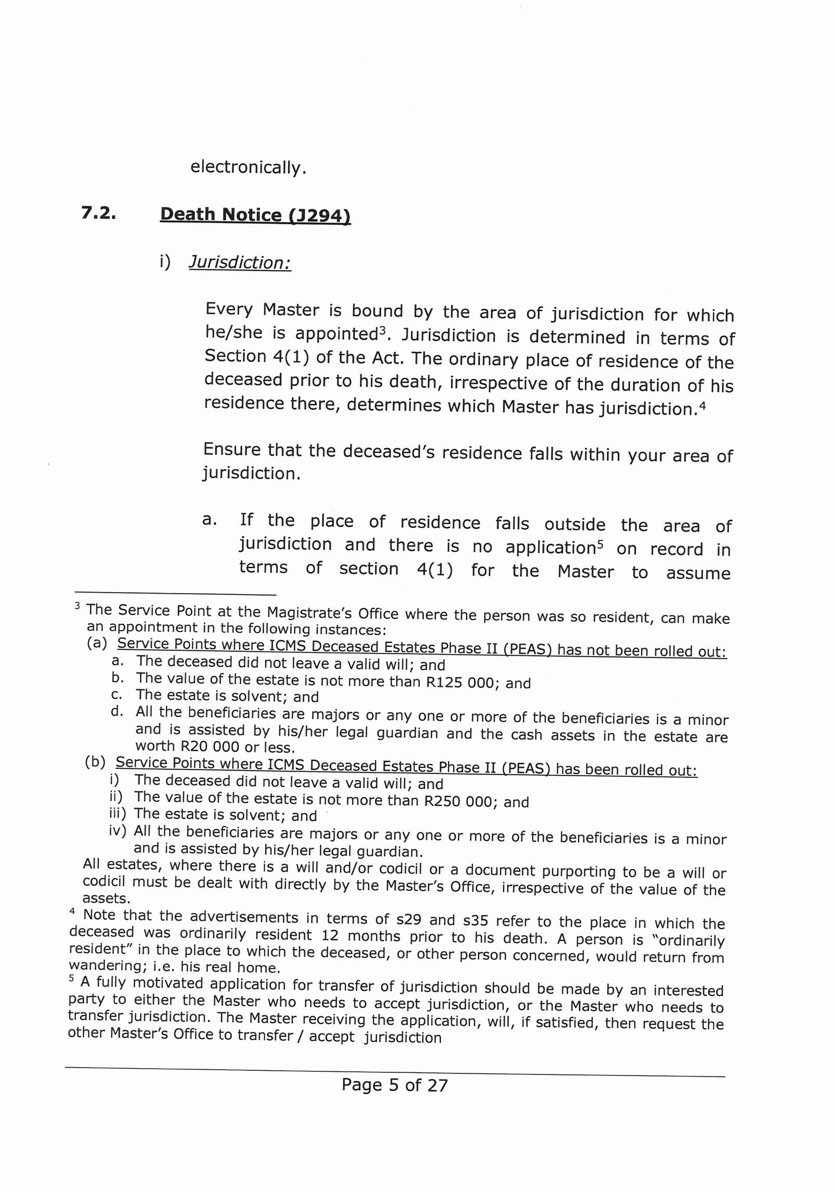

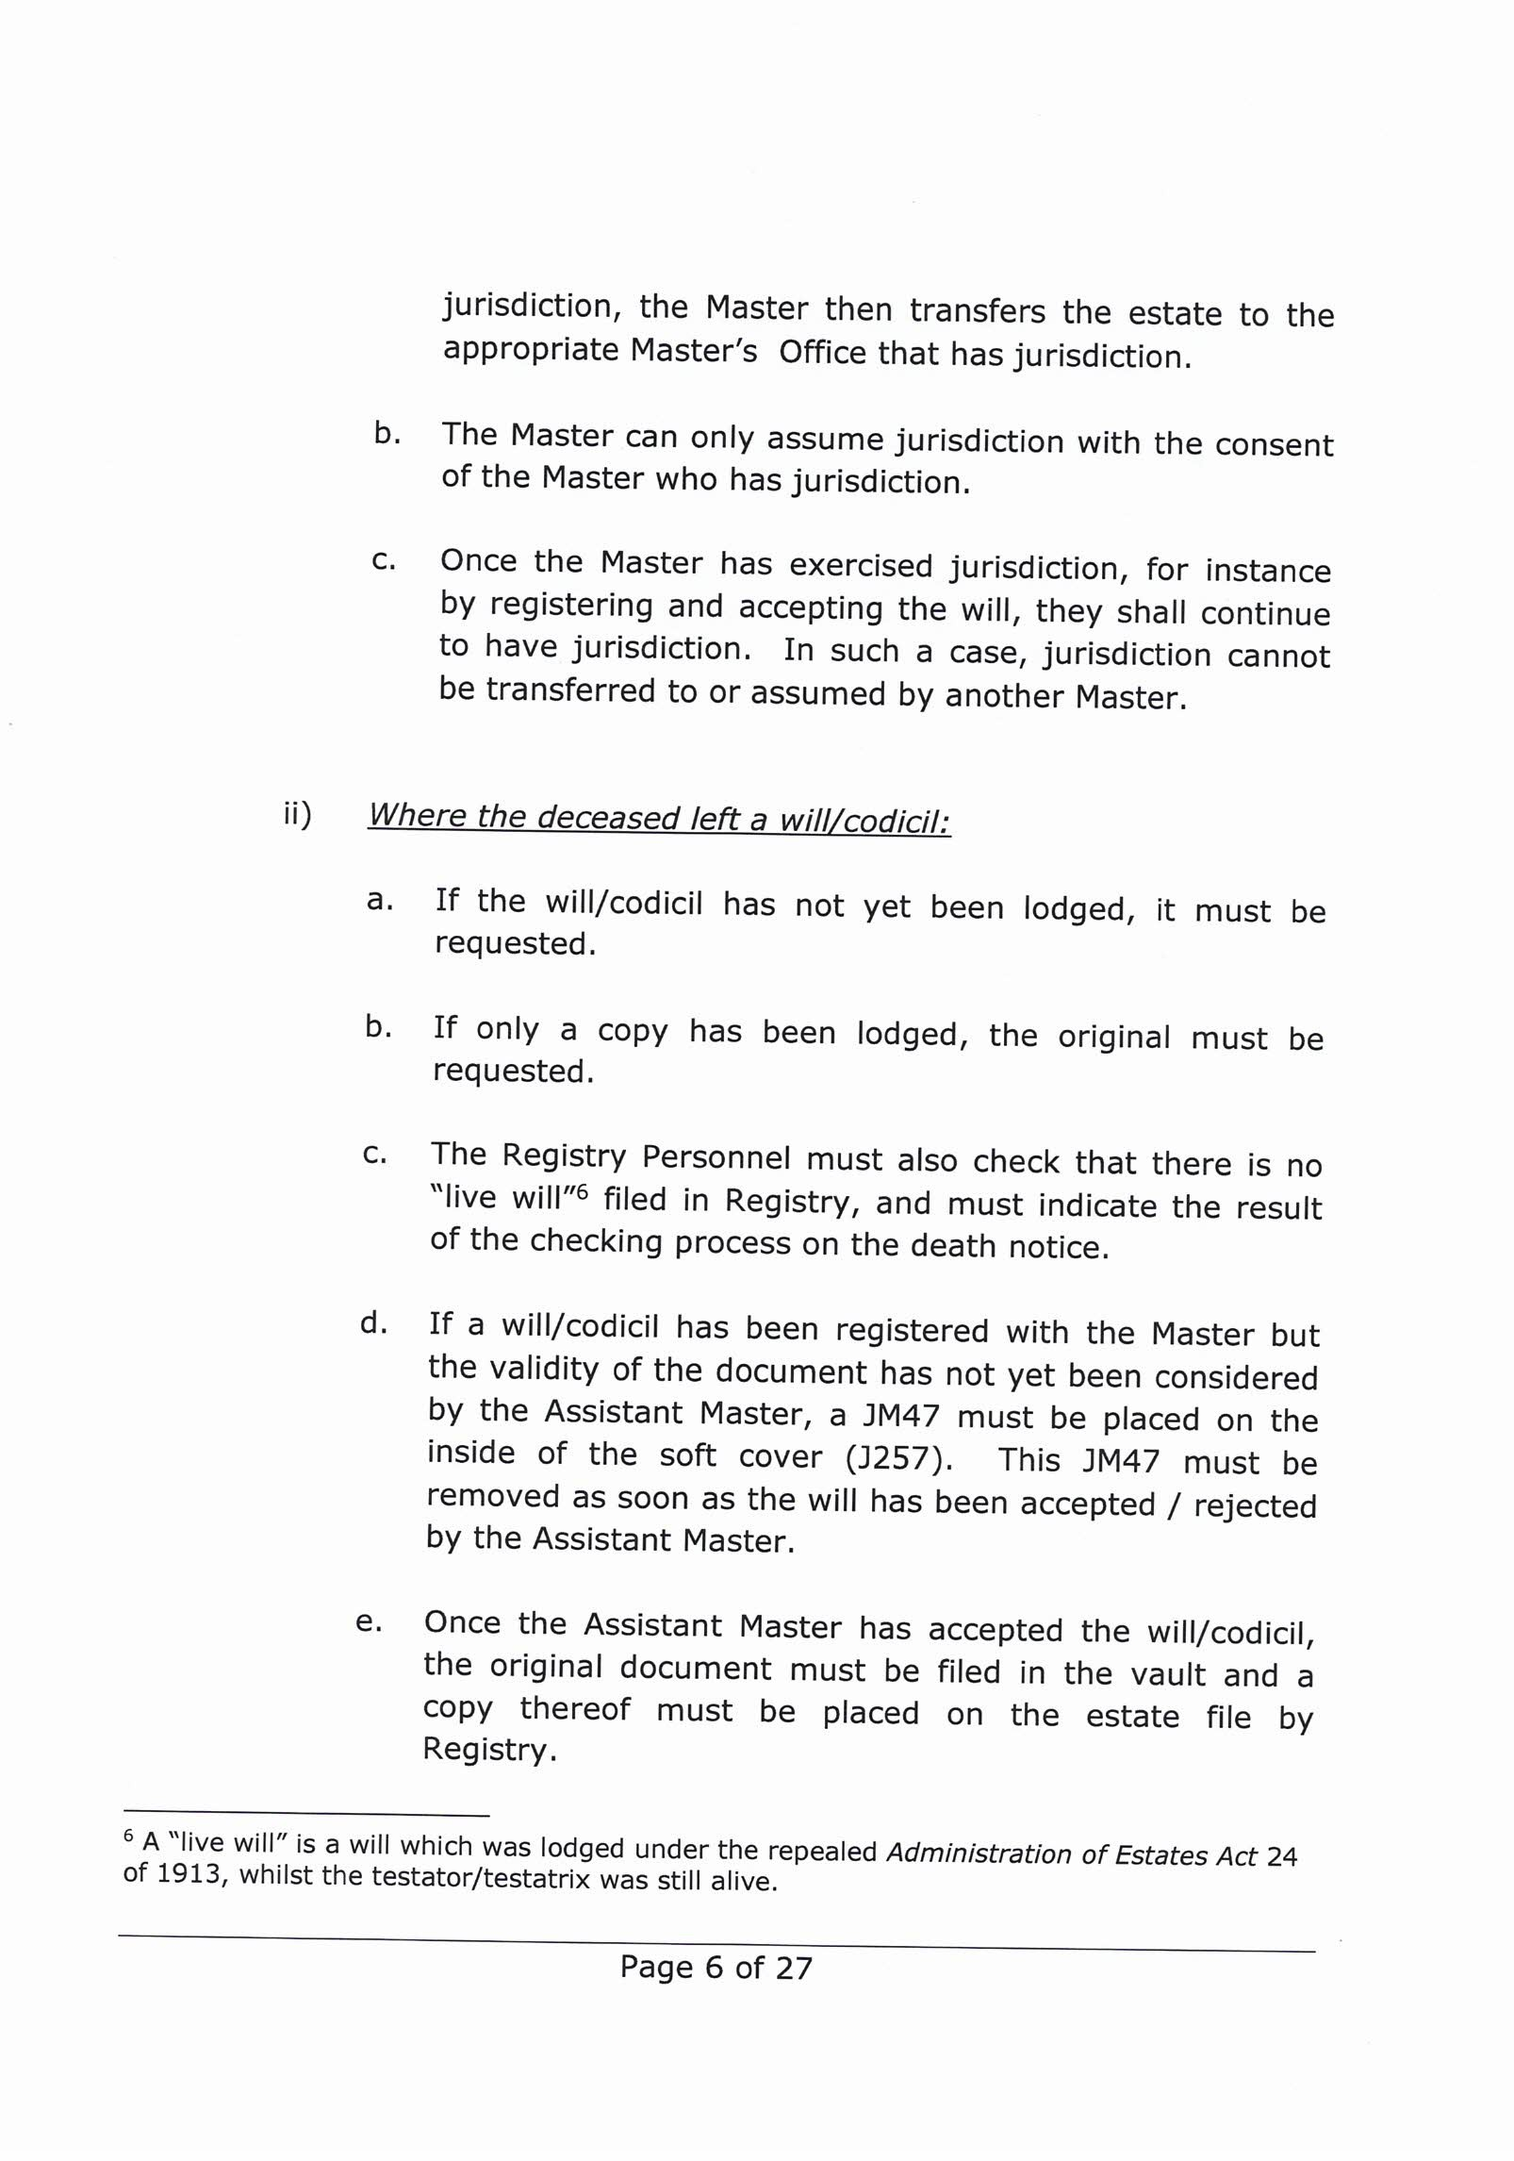

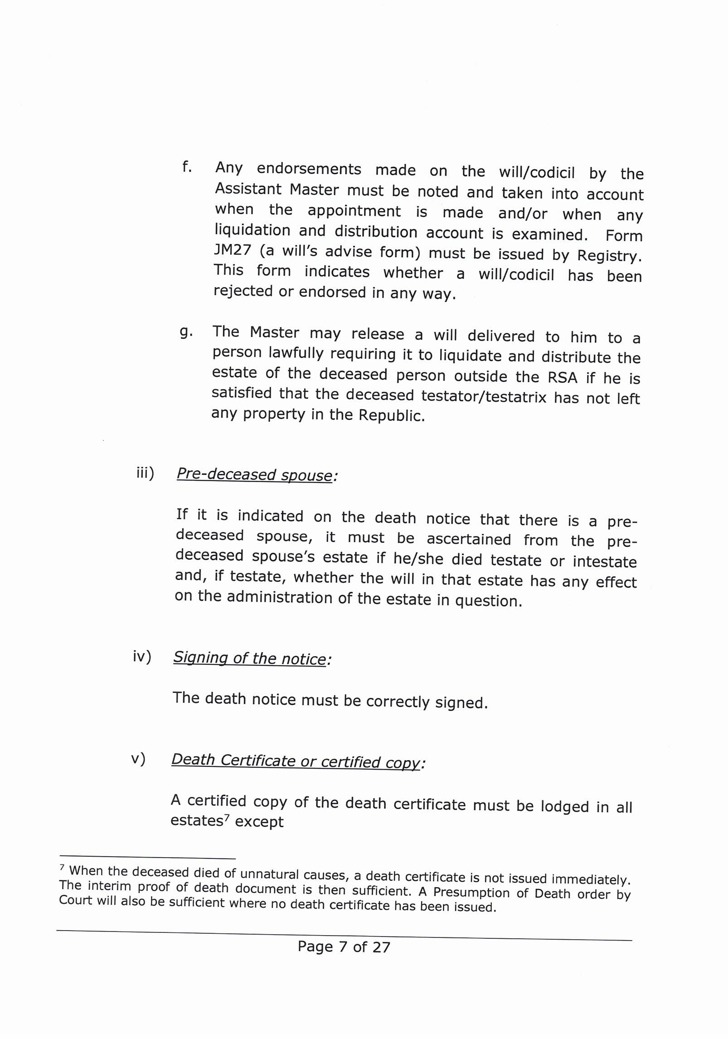

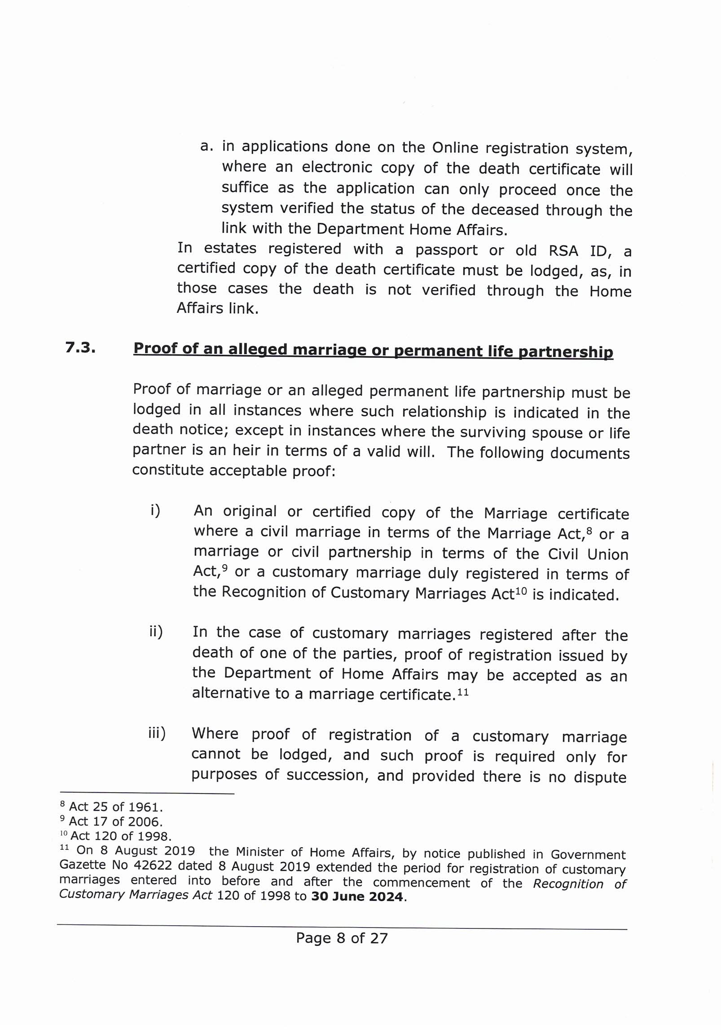

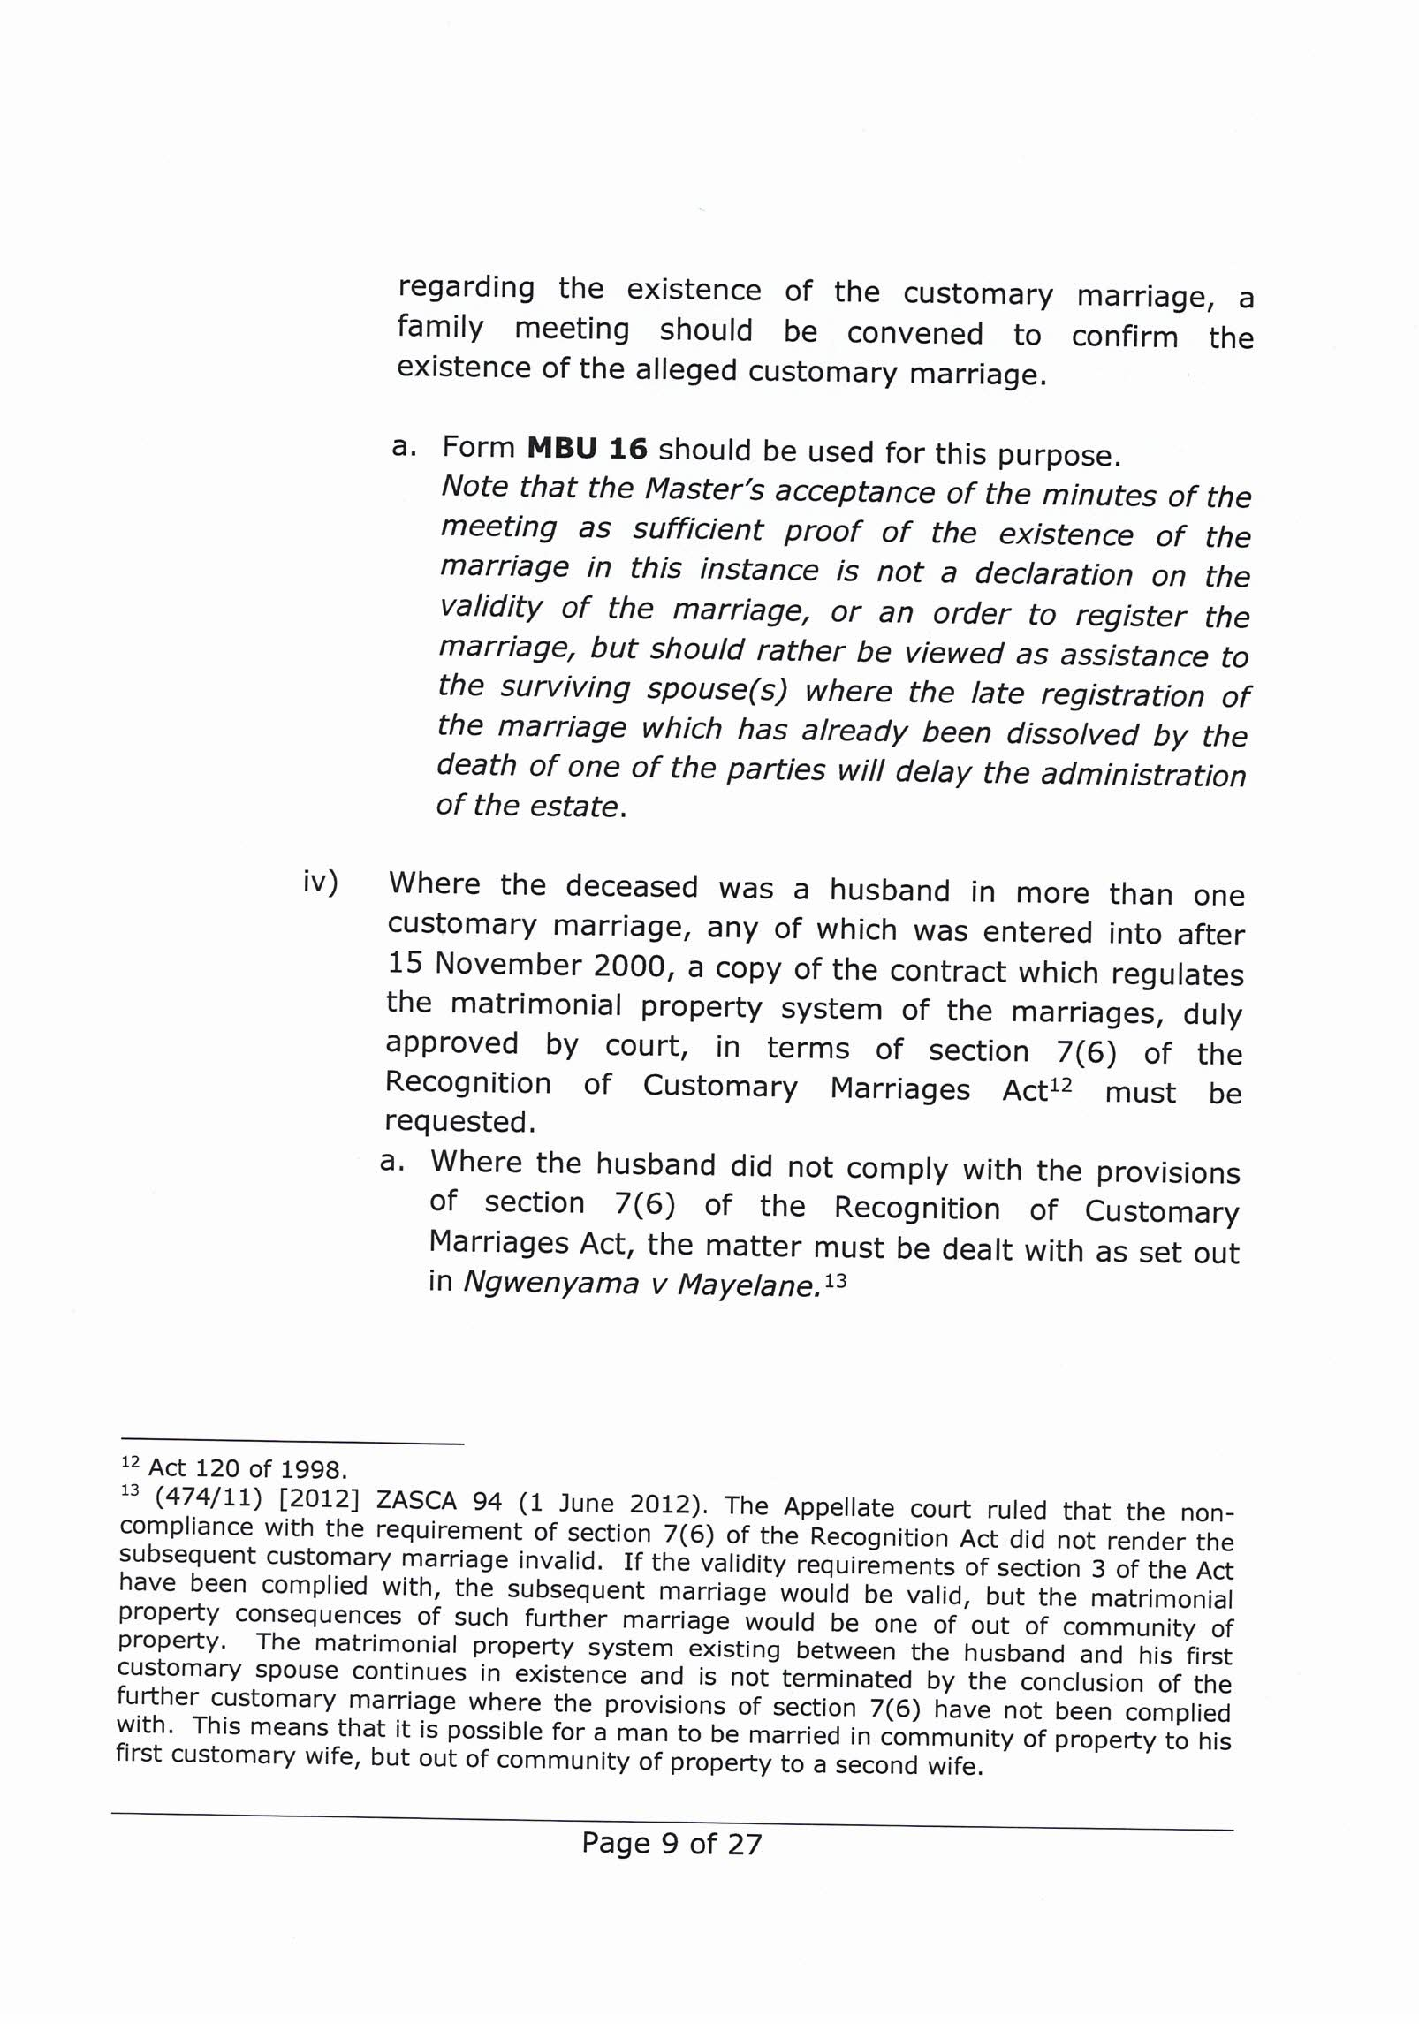

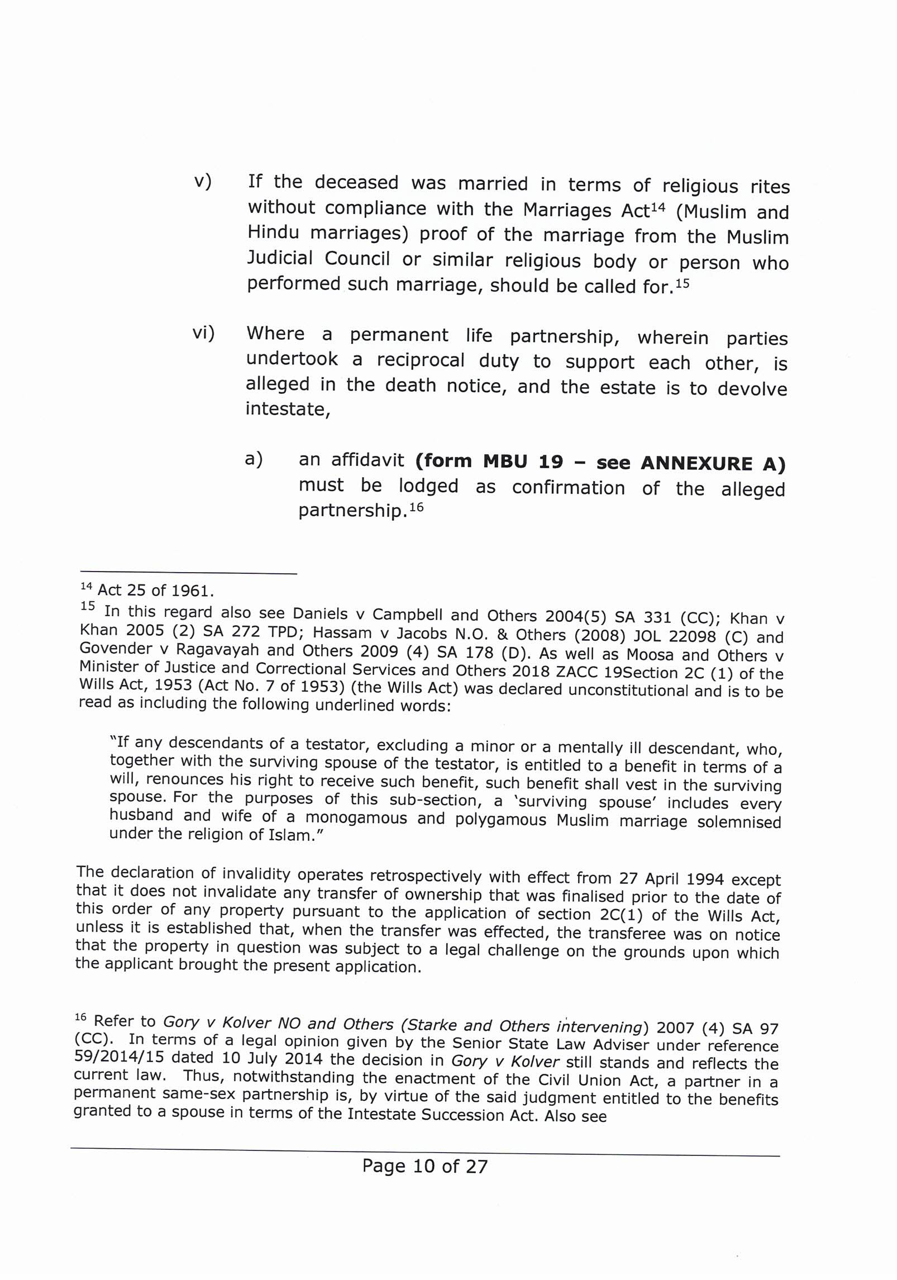

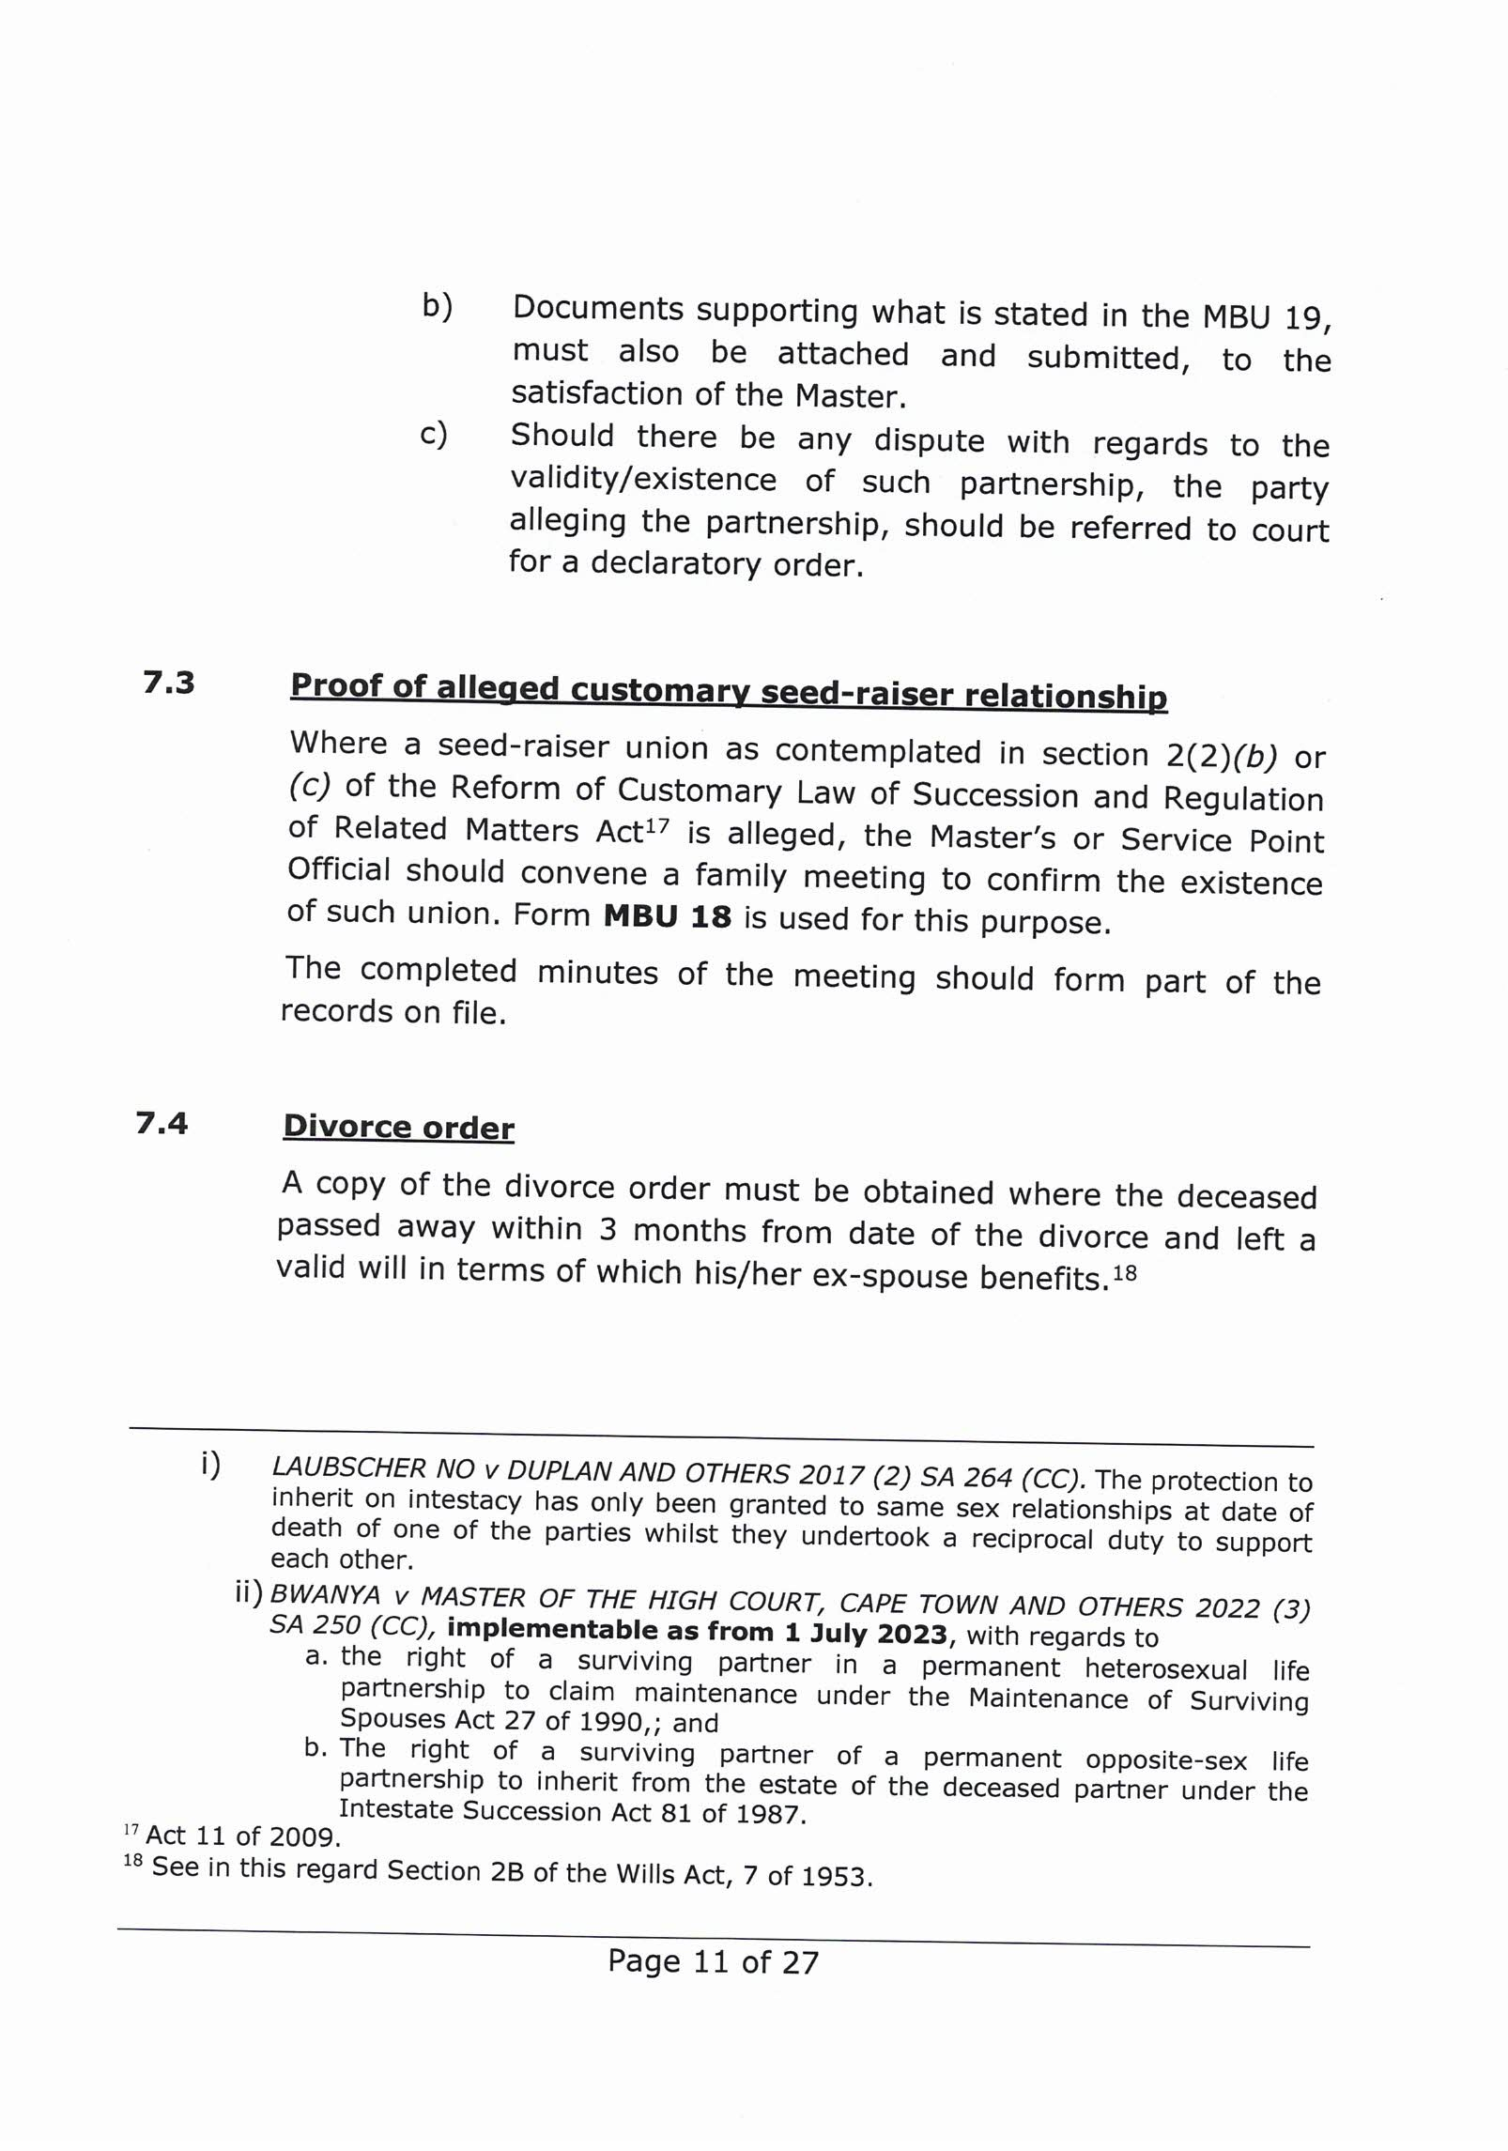

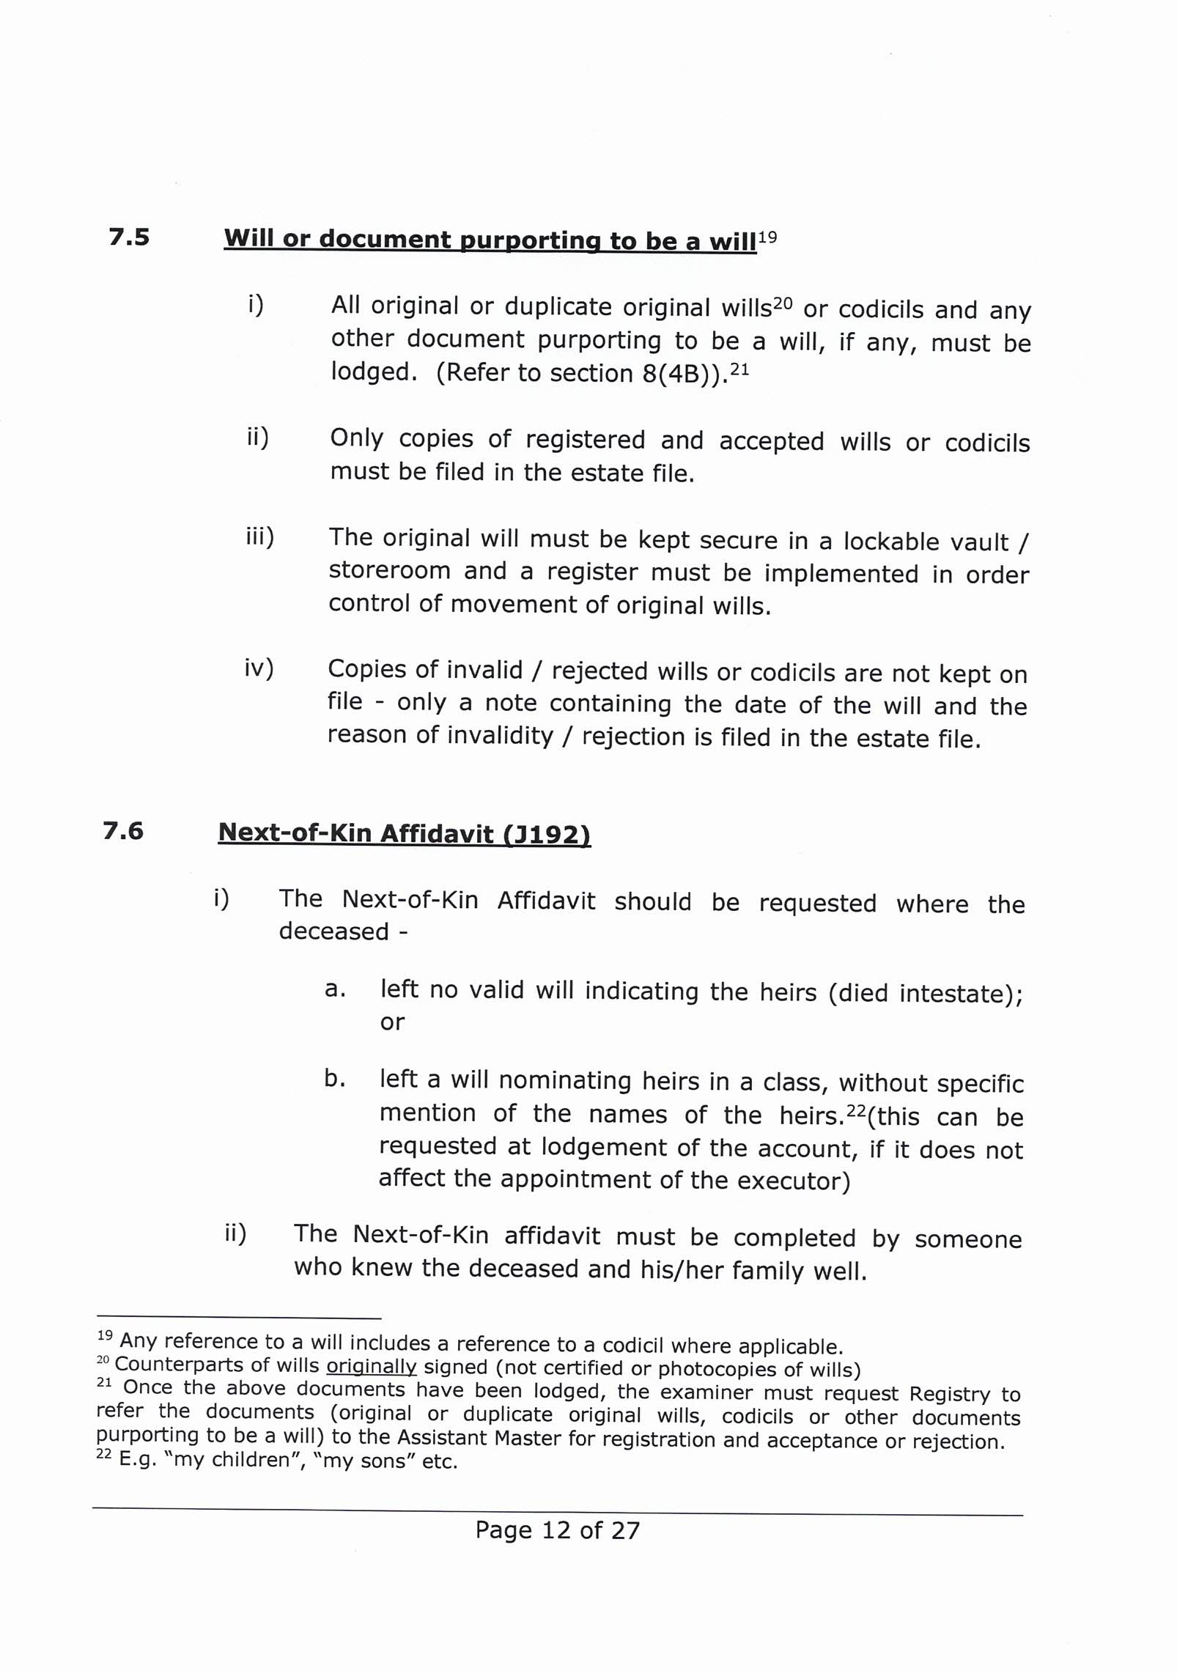

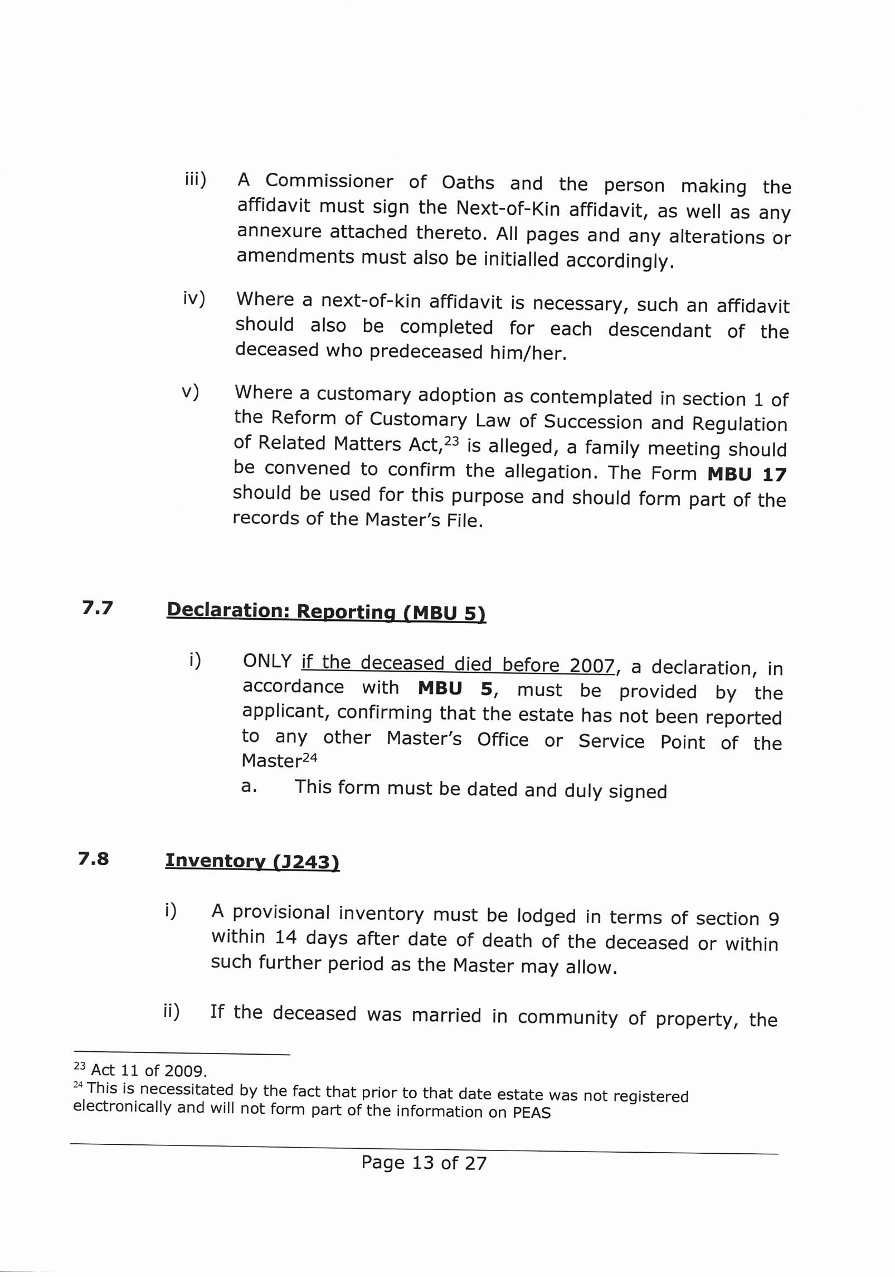

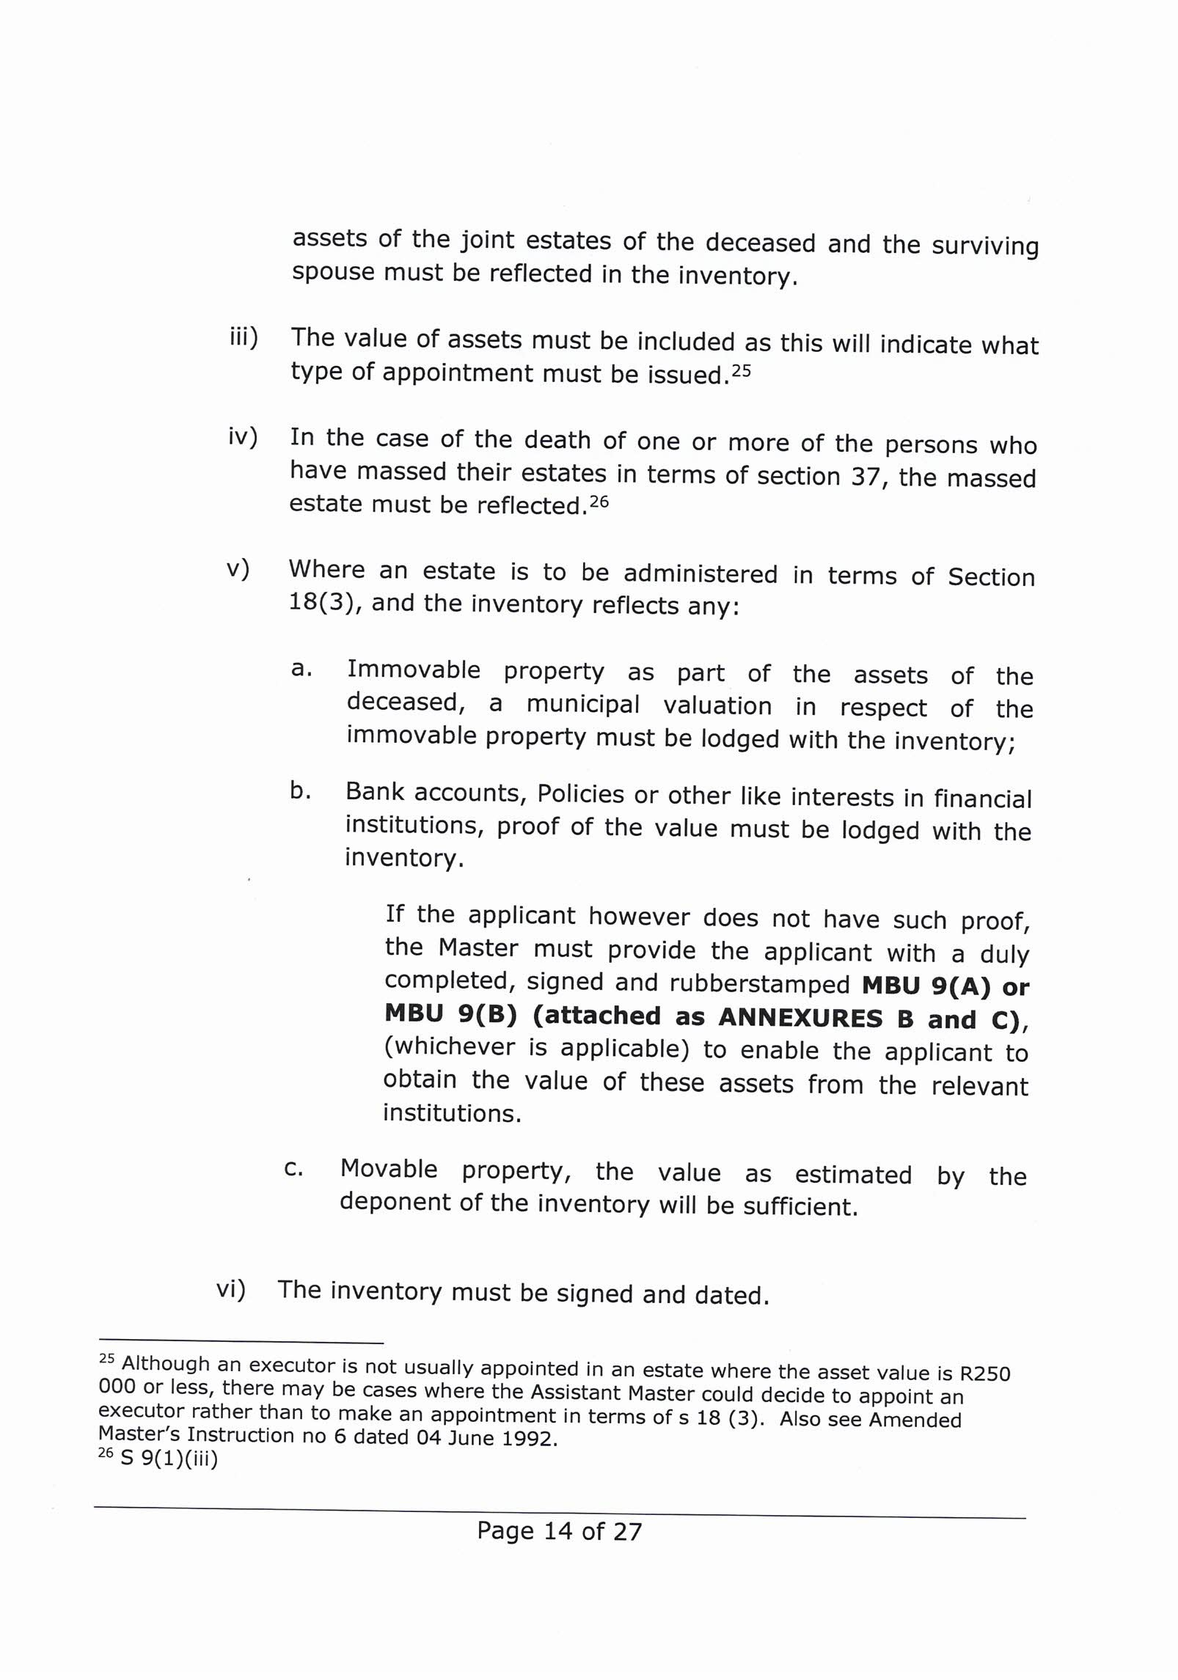

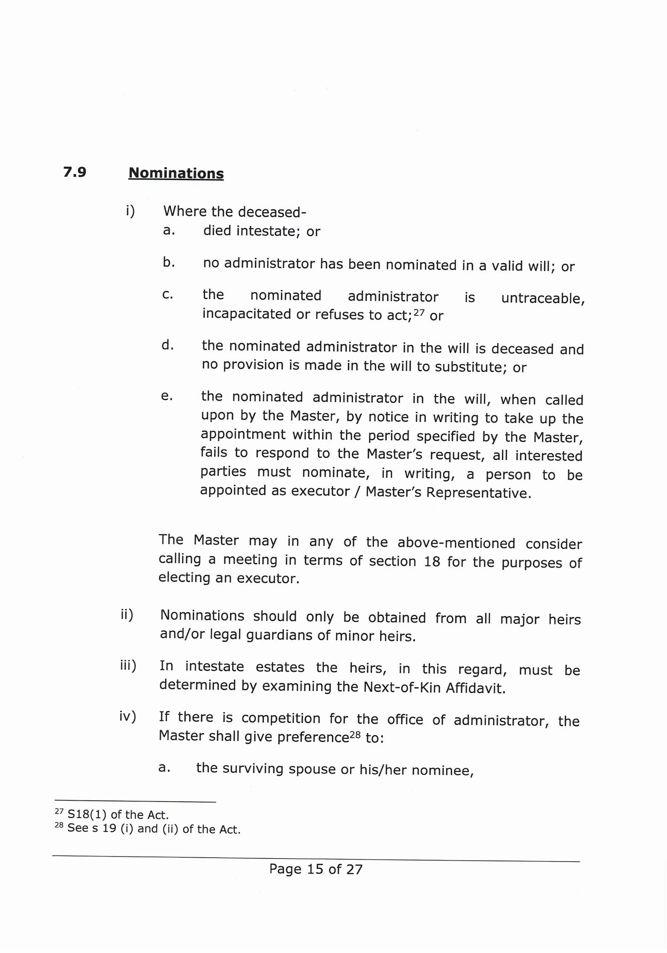

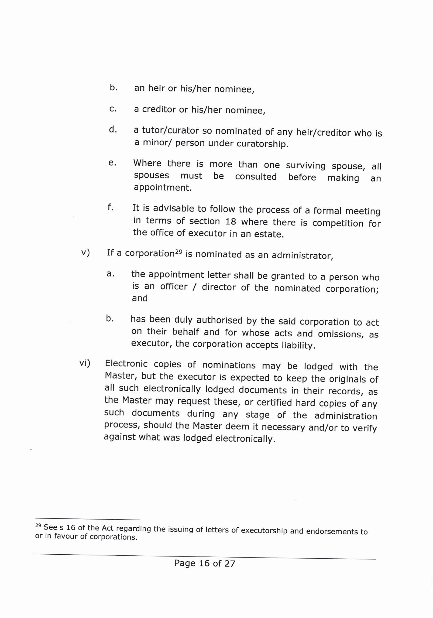

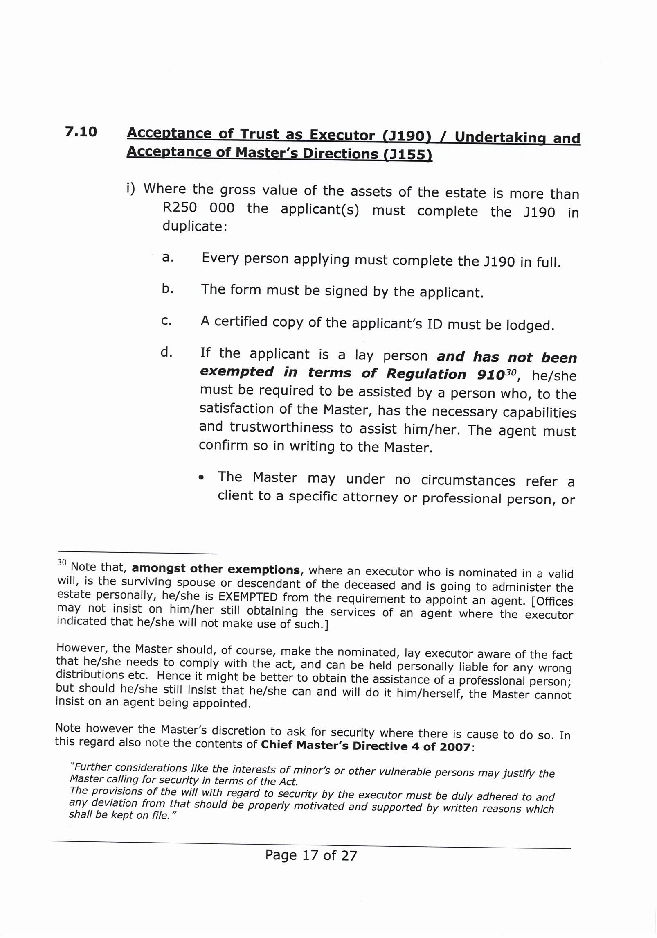

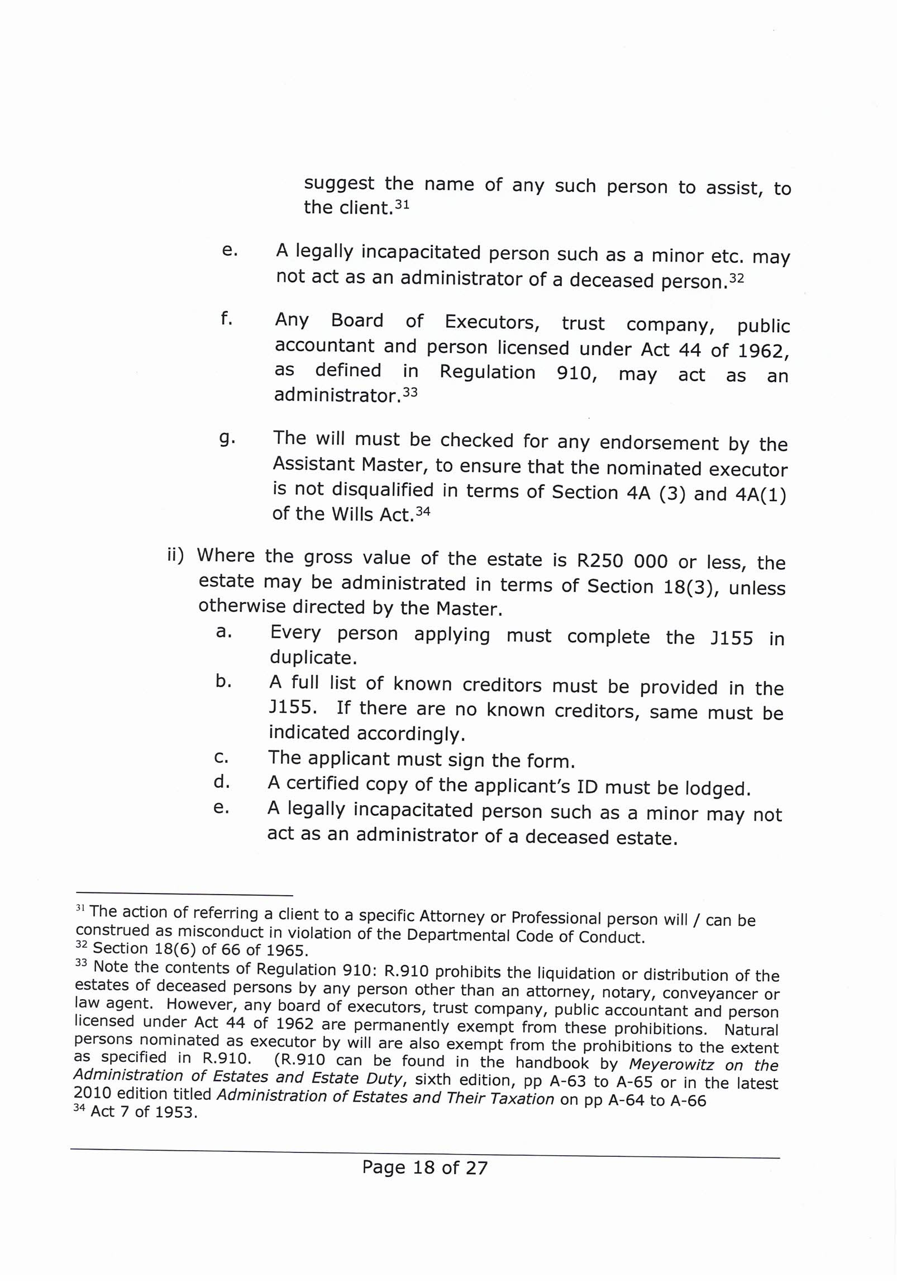

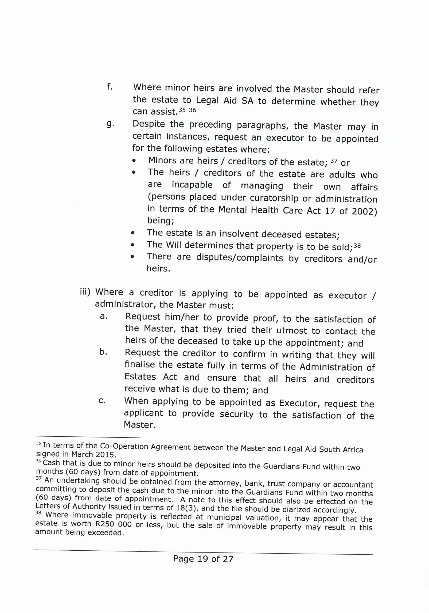

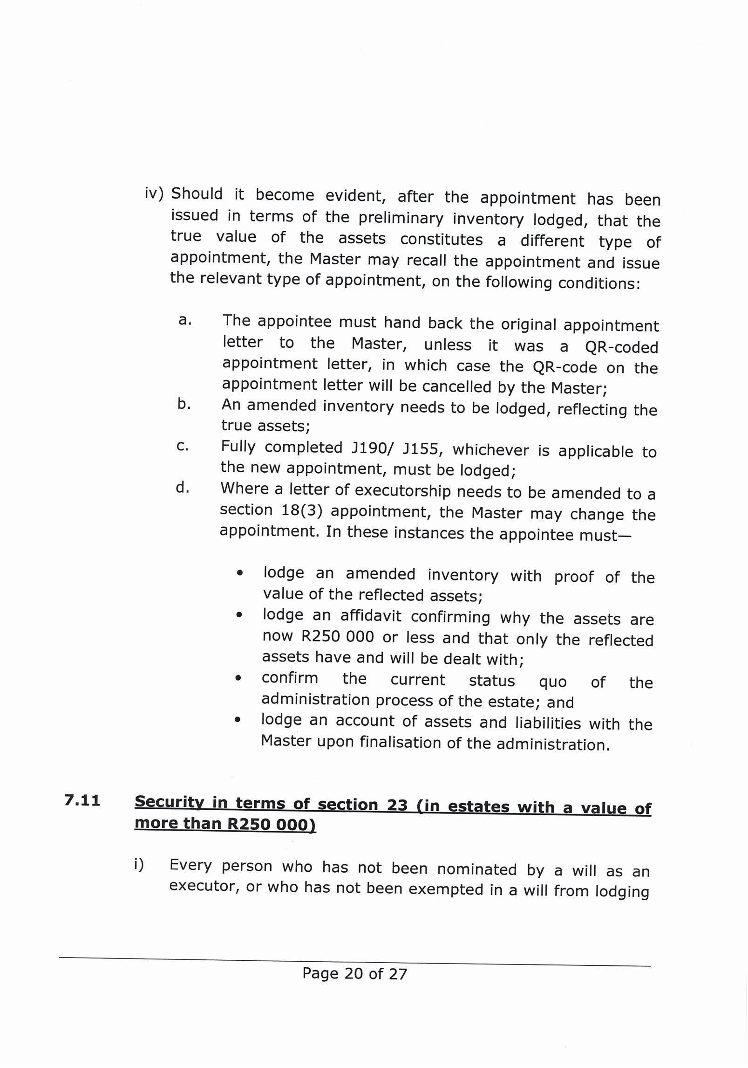

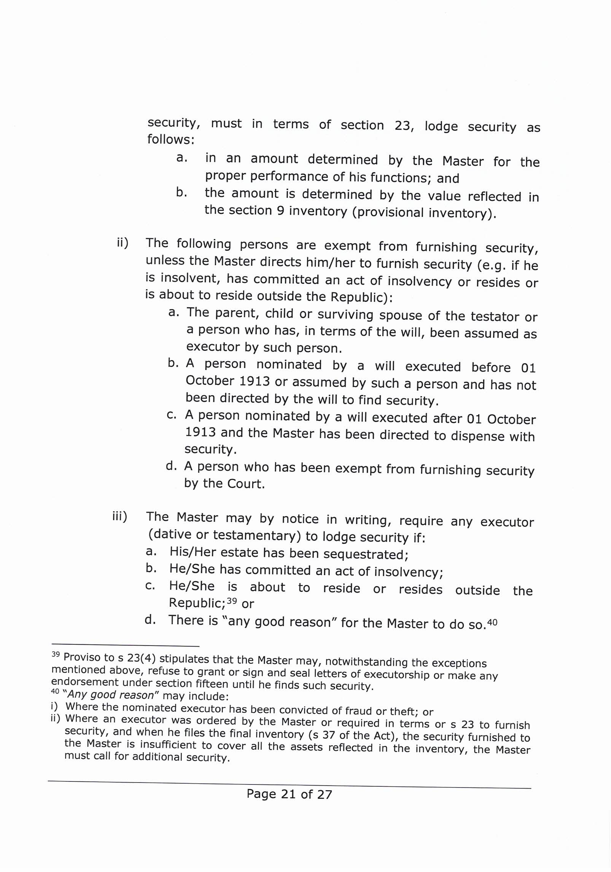

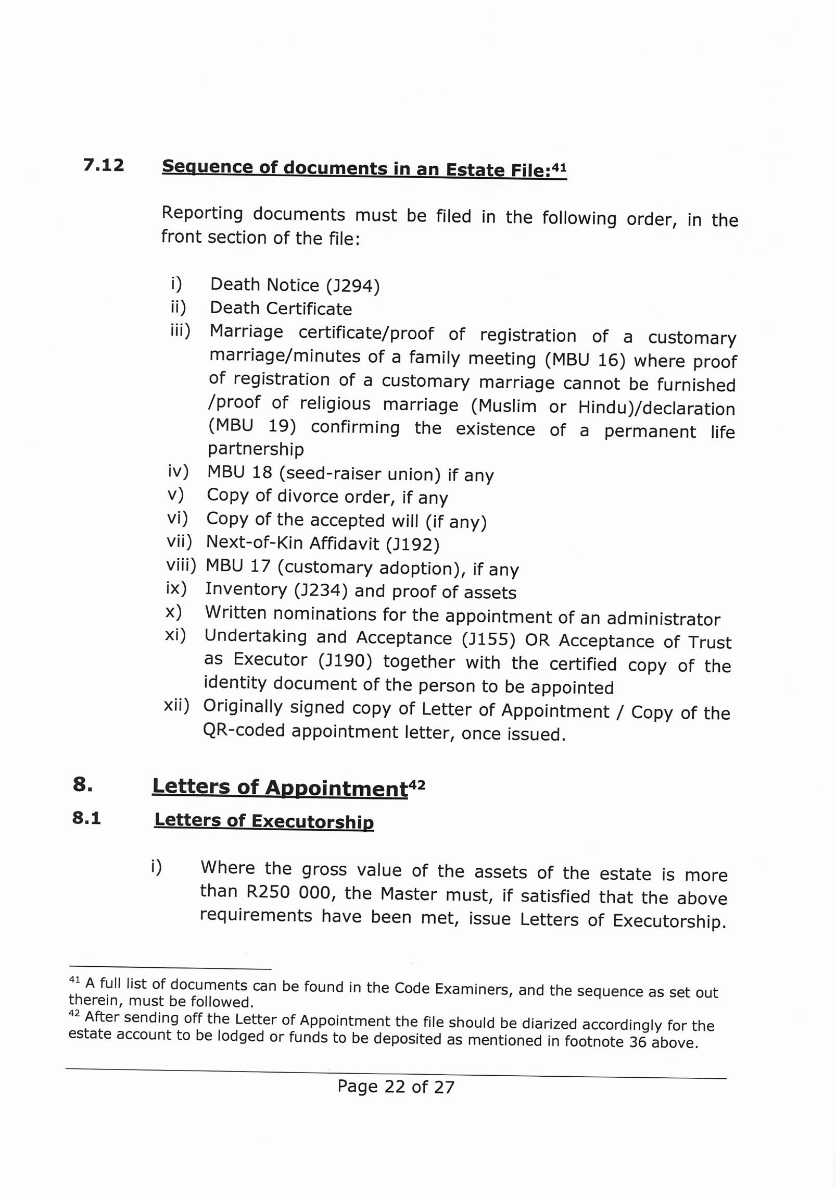

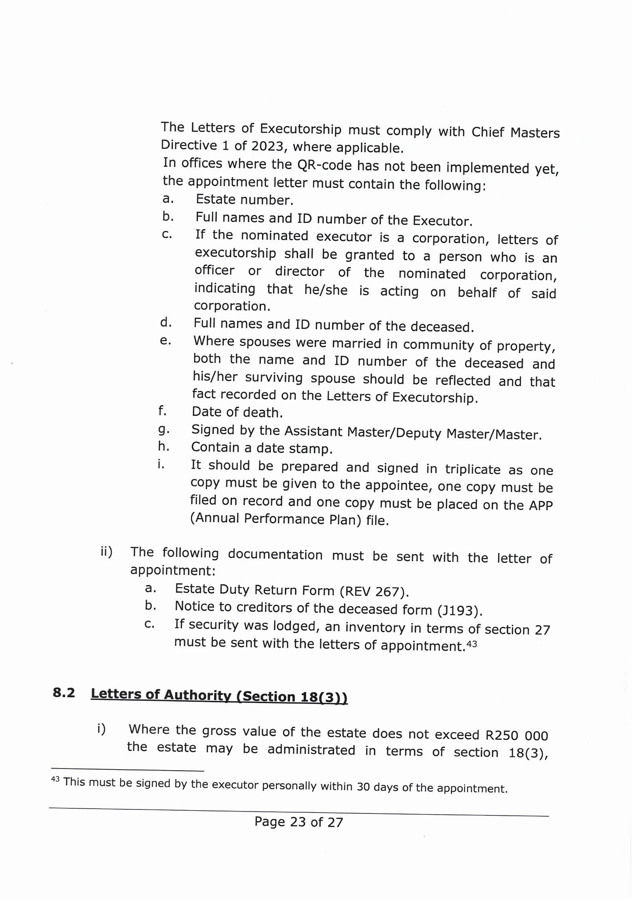

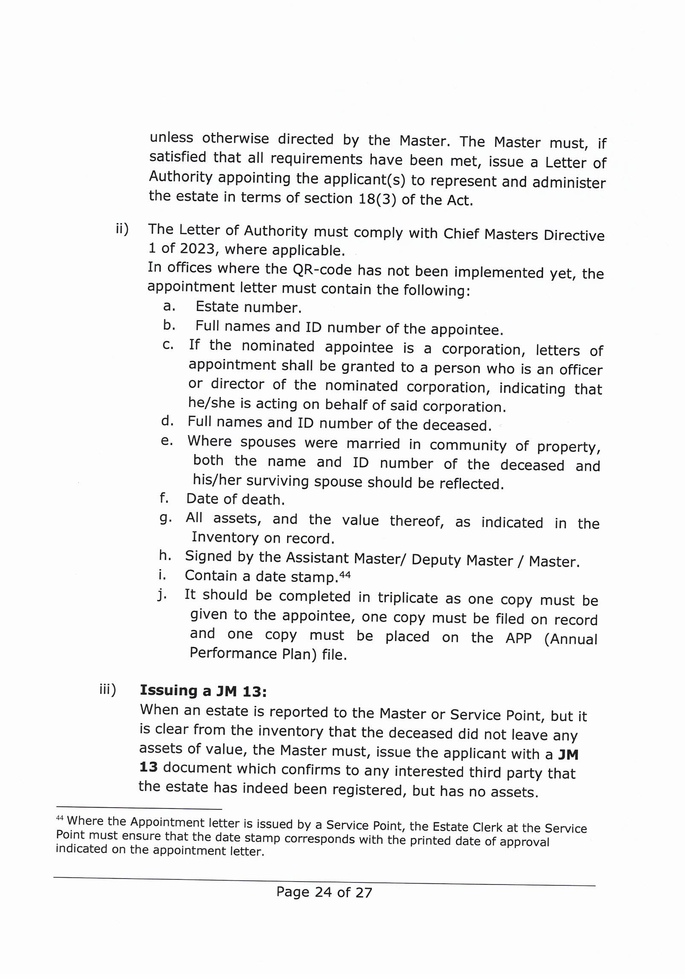

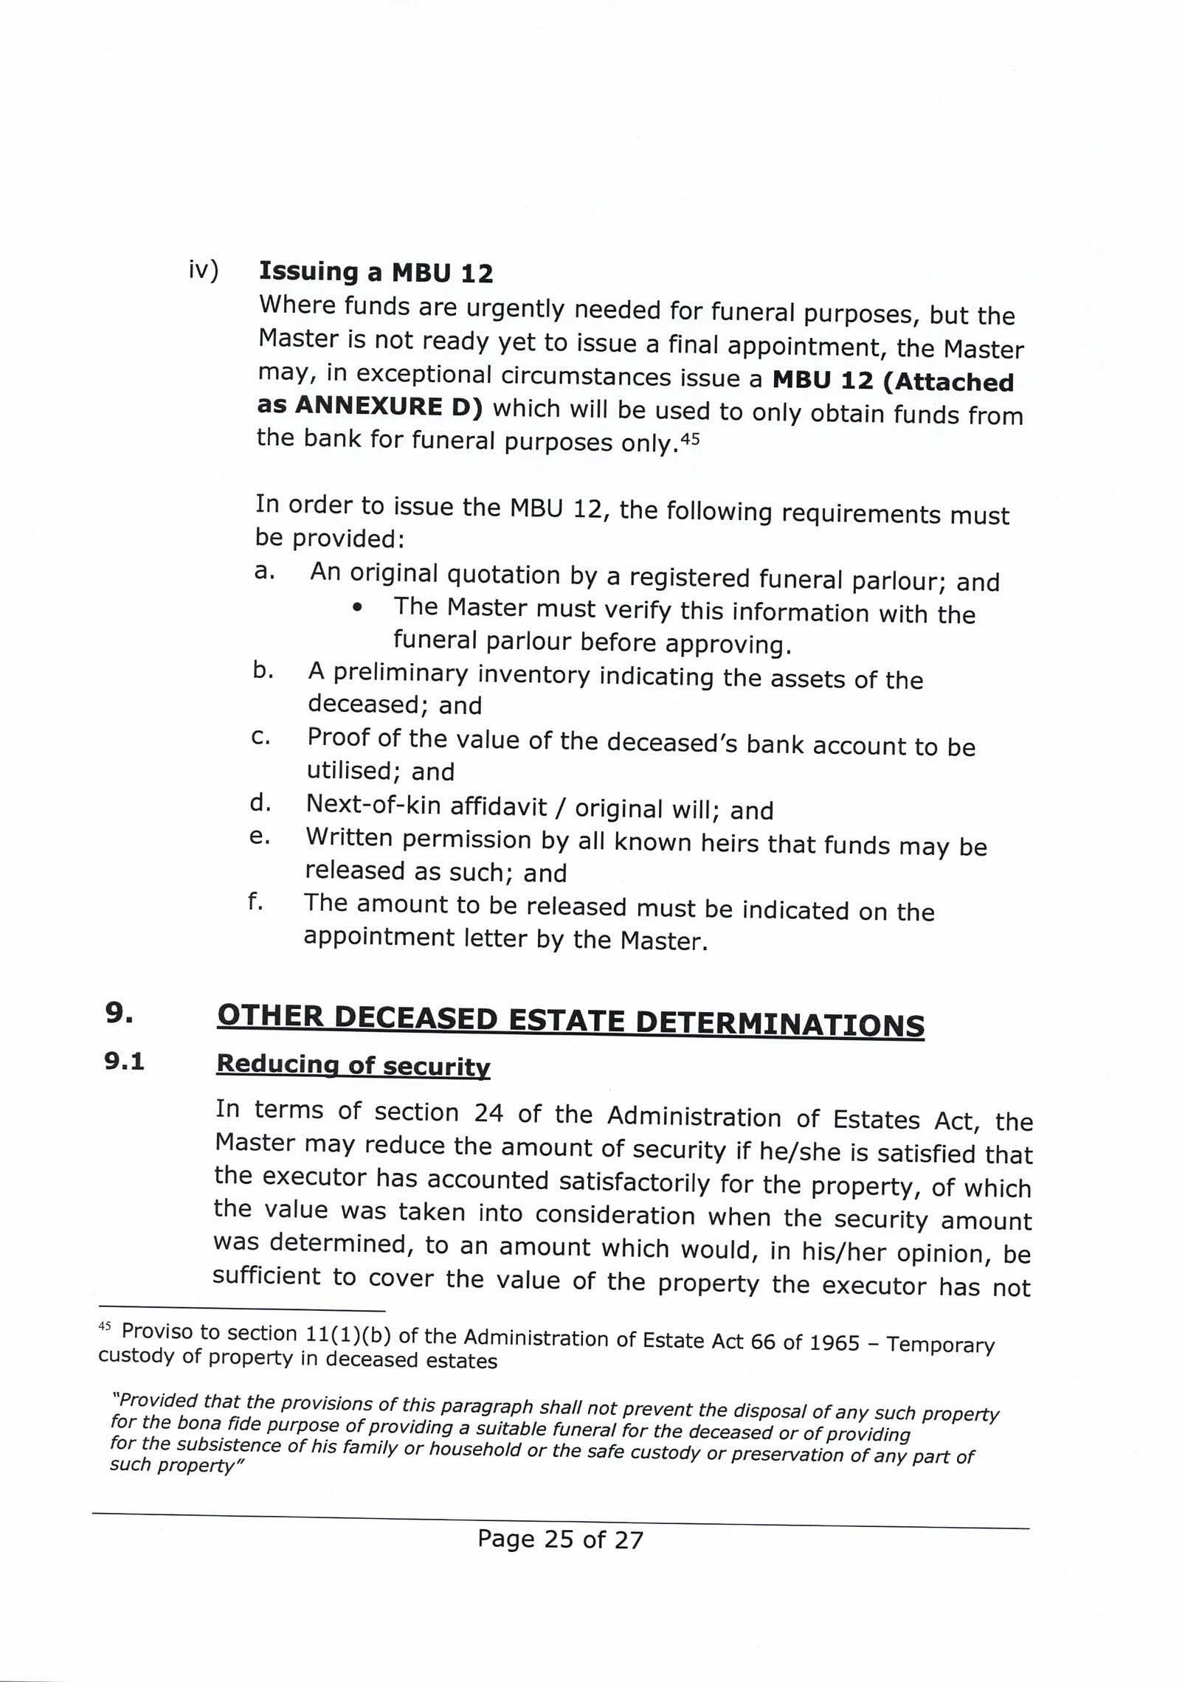

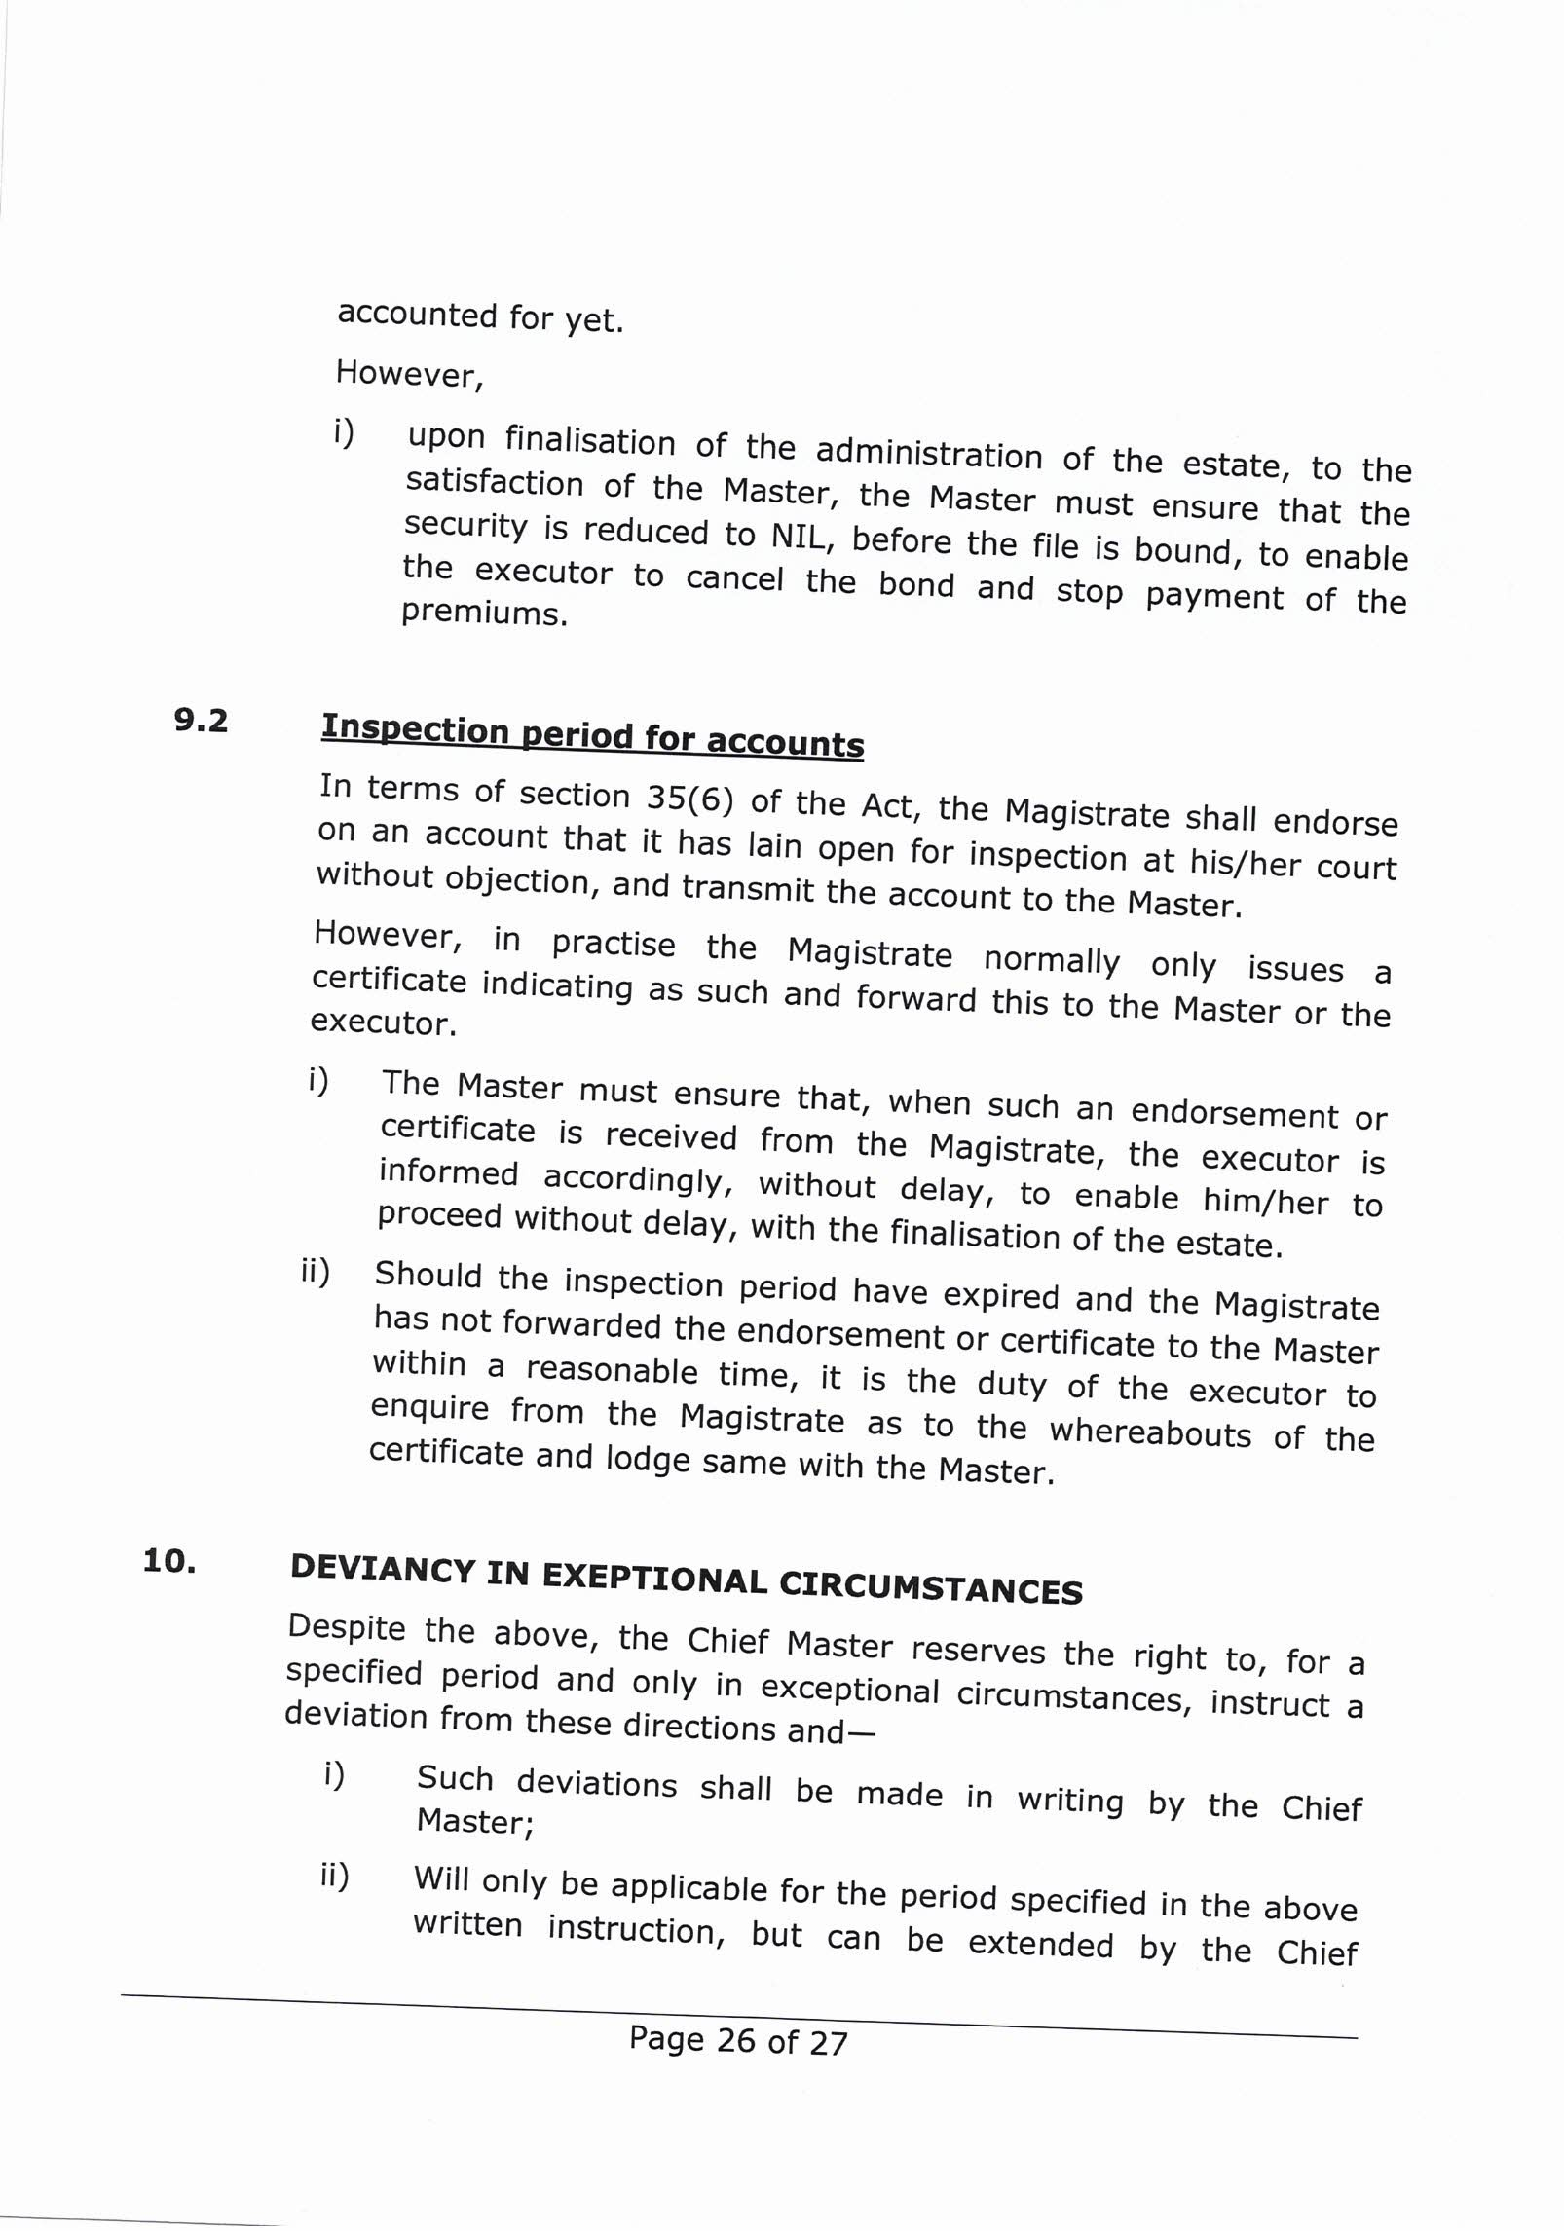

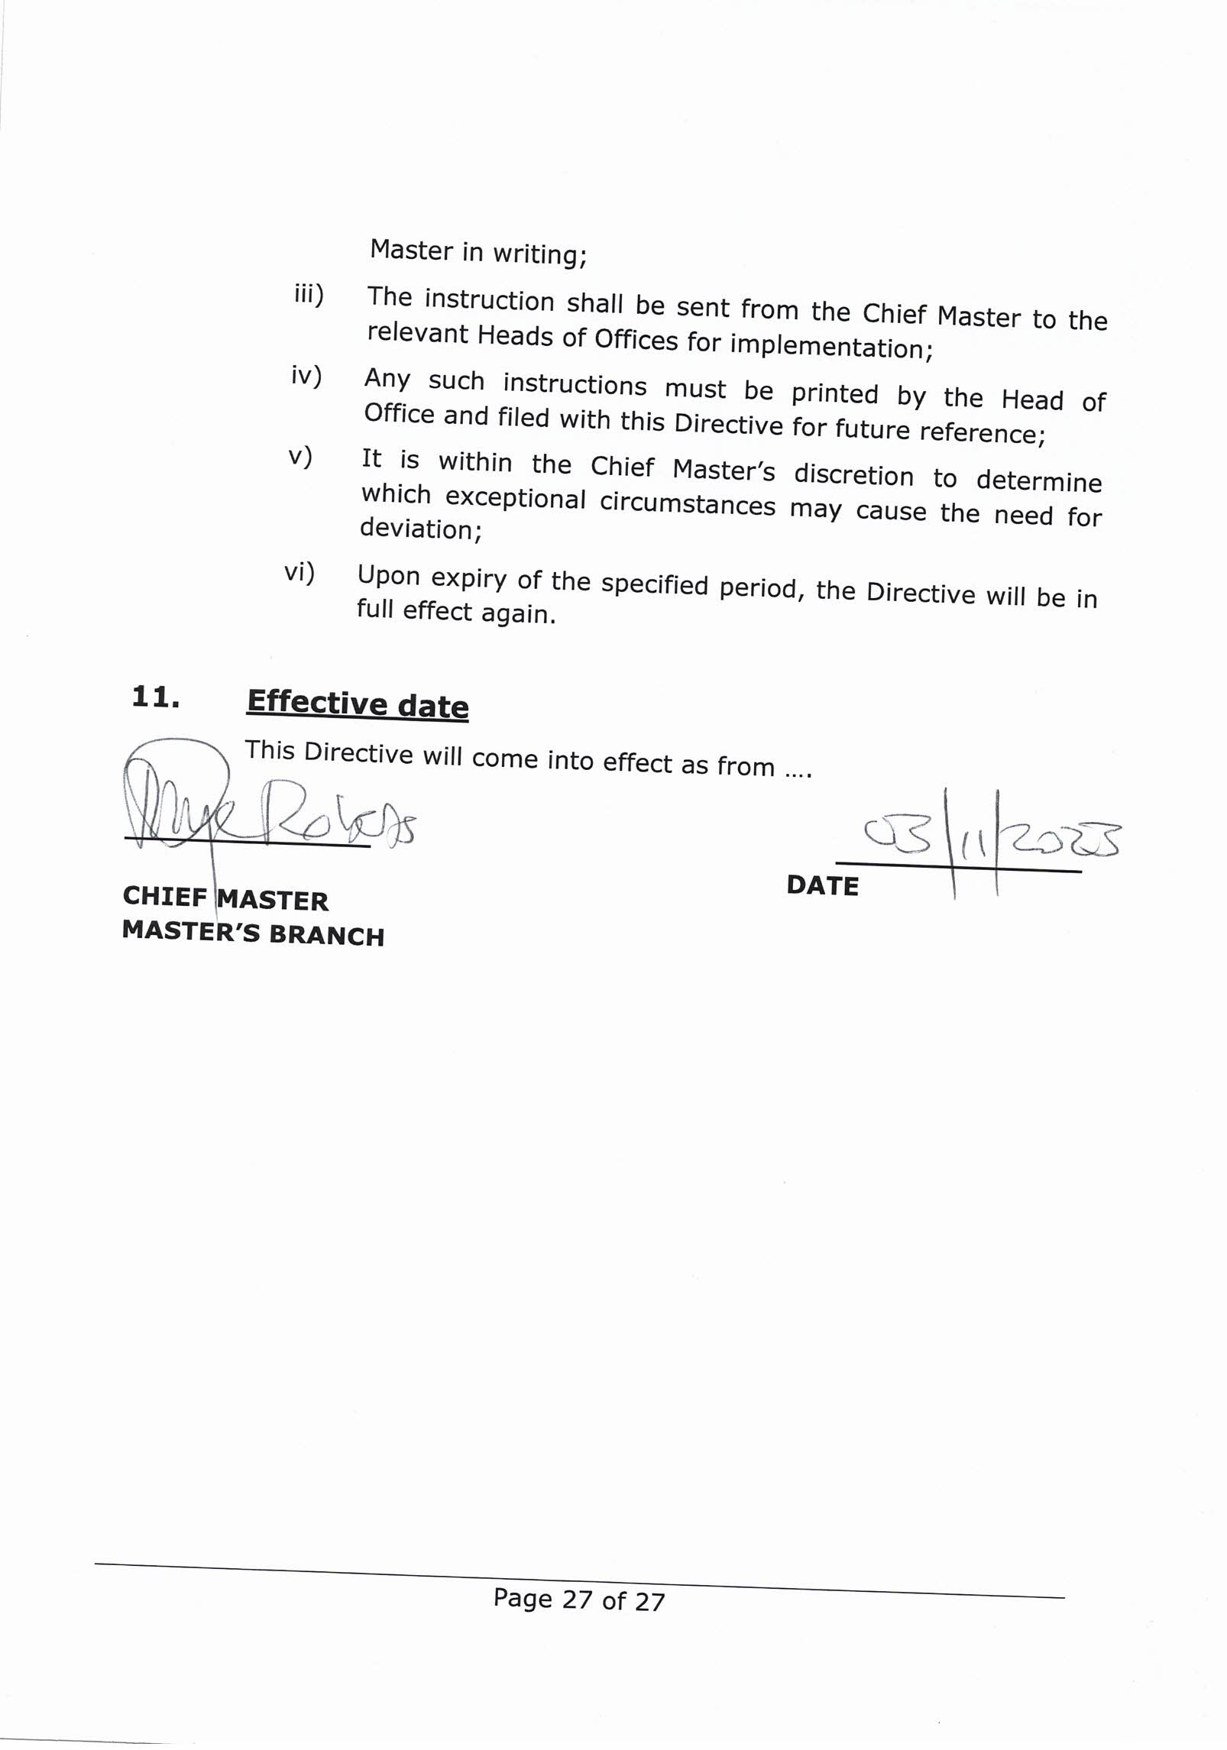

MBU 19


the doj & cd
AFFIDAVIT / AFFIRMATION
Department:
Justice and Constitutional Development REPUBLIC OF SOUTH AFRICA

I, (full names) Identity number of (address)

Declare as follows
The deceased (name & ID number) and I (name of surviving partner)
- were partners in a permanent life partnership; and
- undertook a mutual agreement of support; and
- we cohabitated at the following address:

- the partnership still existed at the time of death of the deceased.

The following facts are submitted as proof of a mutual agreement of support:
This must include all of the following or additional information, by way of an affidavit/affirmation and supporting documents should be attached:
  - the length of the relationship;
  - that the relationship was exclusive of other persons;
  - that the parties shared family responsibilities;
  - affidavits confirming the extent to which the partners were acknowledged by friends and family as life partners;
  - the respective ages of the partners;
  - whether the partners took part in a ceremony manifesting their intention to enter into a permanent partnership, what the nature of that ceremony was and who attended it;
  - whether the partners share a common abode;
  - whether the partners own or lease the common abode jointly;
  - whether and to what extent the partners share responsibility for living expenses and the upkeep for the joint home;
  - whether and to what extent one partner provides financial support for the other;
  - whether and to what extent the partners have made provision for one another in relation to medical, pension and related benefits;
  - whether there is a partnership agreement and what its contents are;
  - whether and to what extent the partners have made provision in their wills for one another;
  - whether the cohabitants have children; and
  - whether they have associated in public as an intimate couple

1

MBU 19

Signature of deponent:
I certify that before administering the oath/affirmation I asked the deponent the following questions and wrote his/her answers in his/her presence.

- Do you know and understand the contents of the affidavit/affirmation?
Answer:
- Do you have any objection to taking the prescribed oath/affirmation?
Answer:
- Do you consider the prescribed oath/affirmation as binding on your conscience? Answer:

I have satisfied myself as to the identity of the deponent and certify that the deponent has acknowledged that he/she knows and understands the contents of the declaration.
The above signature/mark of the deponent has been affixed to the affidavit /affirmation in my presence.

Signed and sworn to/affirmed before me at this day of

Signature of Commissioner of Oaths

Full names of Commissioner of Oaths: Address of Commissioner of Oaths: Area for which appointed

2



MBU 9 (A)

Master of the High Court
Private Bag
Ref:
Date:
Dear Sir or Madam
ESTATE LATE:
In terms of the inventory submitted to my office, the deceased was an account holder at your Bank. The inventory reflects the balance as . Kindly confirm the last available balance from your records.
Name of Account Holder: Identity Number: Bank Account Number: Branch:
Kindly further confirm if the deceased had any other accounts at your bank and the balances thereof.
The above information is required to enable me to exercise my discretion in issuing letters of appointment in terms of section 18(3) of the Administration of Estates Act, 66 of 1965 (as amended) in the estate. Please do not hesitate to contact me, should you have any doubts concerning the validity of this request.

Sincerely,

MASTER OF THE HIGH COURT

MBU 9 (B)

Master of the High Court
Private Bag
Ref:
Date:
Dear Sir or Madam
ESTATE LATE:
In terms of the inventory submitted to my office, the deceased was the owner of a policy with your company which is payable to his/her estate. The inventory reflects the approximate value of the policy as . Kindly confirm the value of the policy according to your records.
Name of the policy owner: Identity Number: Policy Number:
The above information is required to enable me to exercise my discretion in issuing letters of appointment in terms of section 18(3) of the Administration of Estates Act, 66 of 1965 (as amended) in the estate. Please do not hesitate to contact me should you have any doubts concerning the validity of this request.

Sincerely,

MASTER OF THE HIGH COURT

MBU 12

The Masters Office
Private Bag
Ref:
Date:
Dear Sir or Madam
ESTATE LATE:
In terms of the inventory submitted to my office, the deceased was the holder of a savings/cheque* account no. with your Bank, in the amount of approximately R .

Section 11 of the Administration of Estates Act, 66 of 1965 allows a person who holds estate assets, to dispose of any such asset for the bona fide purpose of providing a suitable funeral for the deceased.

The holder of this letter, ** has proved to my satisfaction that an amount of R is required for the reasonable funeral expenses of the deceased.

It will be appreciated if you would release the amount of R to
** to pay for the funeral expenses of the deceased.
Please note that this letter is not an instruction to release the funds, but only a request to do so. Should you have any question regarding the legality of the request, please consult with your Bank’s legal department concerning the matter.
Sincerely,

MASTER OF THE HIGH COURT

* Insert name of Bank.
** Insert name of person to whom funds must be released.

